westsussex.gov.uk

Drug Demand Profile - Chichester

November 2024

Public Health and Social Research Unit

Maria Redon Tardio, [maria.redontardio@westsussex.gov.uk](mailto:maria.redontardio@westsussex.gov.uk)

Contents

Local Context 3

Population and geography 3

Population demographics 4

Ethnicity and nationality distribution 6

Multiple Deprivation and local inequalities 9

Index of Multiple Deprivation (IMD2019) 9

Prevalence 11

Drug Litter 11

Criminal activity and Drug offences 14

BRITISH TRANSPORT POLICE – Drug related incidents 16

Impacts in the community 18

Multiple disadvantage Audit 18

Housing duties and support needs 22

Housing and homelessness support providers 23

Employment and economic inactivity 25

Early Help 26

Children’s Social Care 29

School exclusions and suspensions 33

CGL - Referrals from Education for Under 18s 35

Exploitation 36

Youth Justice Therapeutic and Family Interventions 37

Probation Services 39

CGL – People in structured treatment 41

Naloxone provisions 45

Impacts on health 48

Accident and Emergency attendances 48

Ambulance attendances 53

Deaths related to substance misuse 55

Community engagement 57

Professionals’ Survey 57

Residents’ Survey 66

CGL – Service Users’ Survey 71

‘Serious Violence in West Sussex’ School Survey 77

Dissemination Plan 80

# Local Context

In 2021 the UK Government published a 10-year drugs strategy “From harm to hope: A 10 year drugs plan to cut crime and save lives”. As a result of the new strategy, it was required that every local authority have a strong partnership that brings together all the relevant organisations and key individuals. The West Sussex Drug and Alcohol Partnership (WSDAP) was created with a statutory duty to follow the new national drug strategy: breaking drug supply chains, delivering a world-class treatment and recovery system and achieving a generational shift in the demand for drugs.

The WSDAP understand that to reduce local demand for drugs, it is necessary to work with local partnerships to conduct research activities to create local area profiles of resilience and risk factors of substance misuse for the diverse local geographies across the county, with the ambition to assign partnership leads to the identified priority areas of work resulting from such profiles.

**For a better understanding of the results in this report, it is important to have a clear picture of Chichester population characteristics and its community. Once we know the local context of the study, it should help us to describe and explain some of the analysis and conclusions on this report.**

**To understand Chichester local context we need to focus on:**

* **Population and geography**
* **Population demographics**
* **Multiple Deprivation and local inequalities**

## **Population and geography**

Chichester is on the south coast of England and is a local government district council in West Sussex. It is bordering with Surrey to the North, Horsham and Arun to the East and Hampshire to the West. It is well connected to London and other neighbouring areas by road and rail lines. London is 90 minutes away by direct rail line and 30 minutes to Portsmouth.

Chichester has an area of 786.3 Km² with 124,068 people with a density of 158 people per Km², the least densely populated area of the South East 64 local authorities areas.

Chichester is mostly composed of rural and towns around Midhurst , with some areas are categorised as urban like Chichester, Selsey and the areas close to Haslemere or Emsworth. Most rural areas need over 30 minutes by public transport or walking to access to a Hospital (70% of the population) while in the North of Chichester they will also need over 30 minutes by car (19% population). To access the GP, most population on the West and North will need over 30 minutes walking or by public transport (22% population)[1].

At the time of the 2021 Census, 882,700 people[2] lived in West Sussex of which 124,000 lived in Chichester. Between 2011 and 2021, the population in Chichester increased by 9% this was higher than the South East growth (7.5%). The median age was 48 years, an increase by 2 years compared to 2011 census; the biggest increase in population has been for the groups of age 50 (Figure 1).

The life expectancy at birth for males is 80.6 years and in females is 84.5, similar to West Sussex (80.6 and 84.1 respectively)[3].

Figure 1: Chichester population in 2021 and 2011

Source: ONS, UK Census 2011, 2021

## **Population demographics**

This profile uses a variety of information only available from the Census, such as data on ethnicity, language, so have used the last figures from the 2021 UK census, which are still relevant for the purpose of our analysis.

There are approximately 124,000 people in Chichester, an increased by 9% compared with 2011 UK census. The average growth for the South East has been 7.5% and 9.4% for West Sussex.

Table 1: West Sussex 2021 population by districts and boroughs

|  |  |  |  |  |  |  |  |  |  |  |
| --- | --- | --- | --- | --- | --- | --- | --- | --- | --- | --- |
| **Population** | **Adur** | **Arun** | **Chichester** | **Crawley** | **Horsham** | **Mid Sussex** | **Worthing** | **West Sussex** | **South East** | **England** |
| **2011** | 61,182 | 149,518 | 113,794 | 106,597 | 131,301 | 139,860 | 104,640 | 806,892 | 8,634,750 | 53,012,456 |
| **2021** | 64,544 | 164,889 | 124,068 | 118,493 | 146,778 | 152,566 | 111,338 | 882,676 | 9,278,065 | 56,490,048 |
| **Change** | 3,362 | 15,371 | 10,274 | 11,896 | 15,477 | 12,706 | 6,698 | 75,784 | 643,315 | 3,477,592 |
| **% Change** | 5.5% | 10.3% | 9.0% | 11.2% | 11.8% | 9.1% | 6.4% | 9.4% | 7.5% | 6.6% |

Source: ONS, UK Census 2011, 2021

If we compare Chichester with nearby areas like [Horsham](https://www.ons.gov.uk/visualisations/censuspopulationchange/E07000227) and [Arun](https://www.ons.gov.uk/visualisations/censuspopulationchange/E07000224), they have seen their populations increase in a bigger proportion by around 11.8% and 10.3% respectively, while Havant and Waverley they have grown in lower proportion with 2.9% and 5.5% respectively.

It is also important to note that in Chichester the age group below 14 has experienced a more moderate growth than most districts in West Sussex, just Worthing has seen a lower growth in this group (Figure 2).

Figure 2: 2011-2021 Population Percentage Change by Age Group West Sussex Source: ONS, UK Census 2021

If we compare the data we have from ONS Census 2011 and 2021 Census (Figure 3) we can see how the population has changed. In recent years has been less births and the group of age between 40 and 49 has also been reduced, while the groups of age over 70 has increased. All of these would explain that the population is aging in the area.

Figure 3: 2011-2021 Population Percentage Change by Age Chichester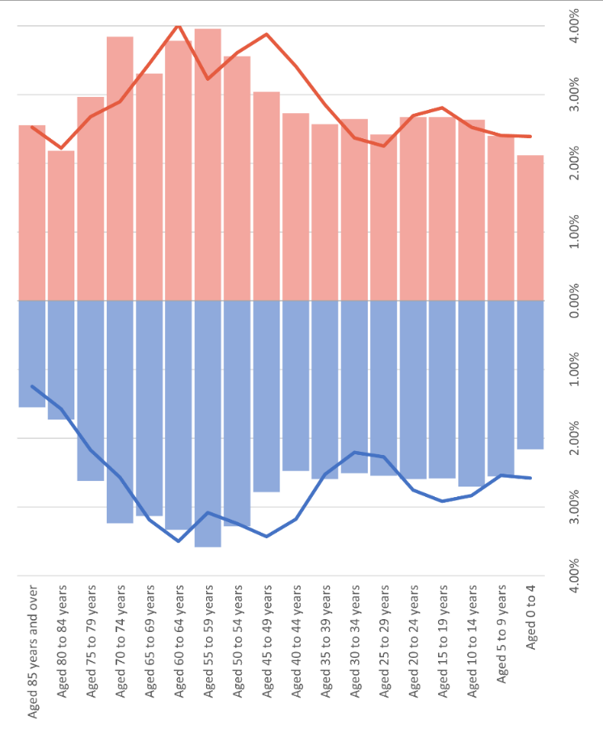

Source: ONS, UK Census 2011, 2021

Figure 4: 2011-2021 Population Percentage Change by Age Englandan 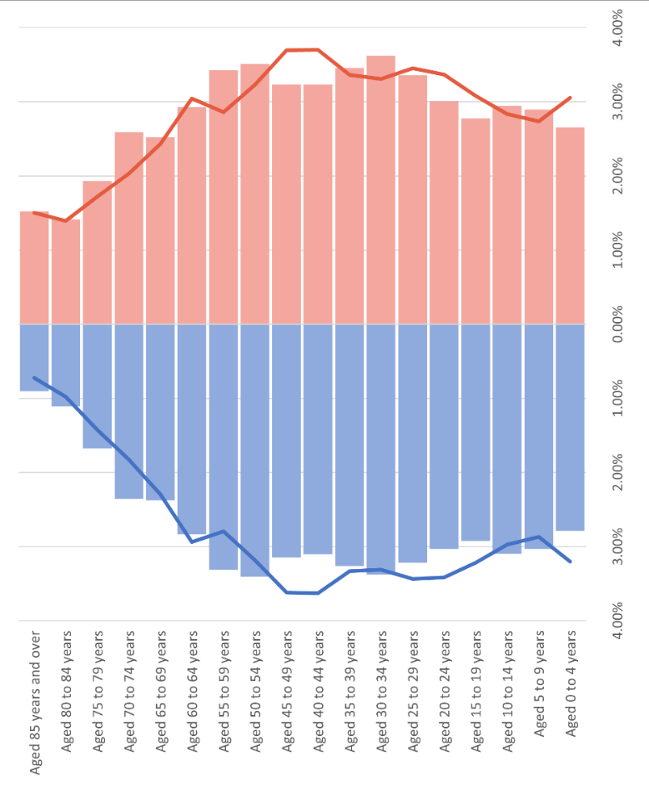

Source: ONS, UK Census 2011, 2021

If we compare the population pyramids between Chichester and England (Figure 3 and 4), we can see that Chichester has an older population. In Chichester the proportion of population from 55 is bigger than England, 41.75% and 30.91% respectively, while the proportion of young people from 15 to 39 is smaller, 25.77% and 32.03%.

### **Ethnicity and nationality distribution**

Minority ethnic communities in West Sussex are increasing across all seven districts and boroughs, of note Crawley, the percentage of the population from an ethnic minority has increased by over 10% in the last 10 years (Figure 5). In Chichester minority group have increased from 7% of the population in 2011 to nearly 10% in 2021. The minority group with highest increase in representation is ‘Other White non UK ethnic’ which represent 5.31% of Chichester population.

Figure 5: West Sussex - BAME composition 2011 - 2021 (Includes ‘White Irish’, ‘Gypsy/Traveller’, ‘Roma’ and ‘Other white’. Source: ONS, UK Census 2011, 2021

If we analyse the population by country of birth, 8% of the population was born outside the UK, being the majority from EU countries. From the people born outside the UK, the vast majority are aged between 25 and 64 years (Figure 6).

Figure 6: Chichester - Age population by country of birthSource: ONS, UK Census 2011, 2021

Analysing the level of education of those born outside the UK (Figure 7) we can see the proportion with Level 4 (e.g., university education) or above is higher than the population born in UK, especially people born Middle East and Asia and the Americas and the Caribbean.

Figure 7: Chichester – Highest level of qualification by country of birthSource: ONS, UK Census 2011, 2021

People living in Chichester coming from outside UK are more likely to be between 25 to 64 with higher level of education.

**First language**

In Chichester there are a variety of main languages spoken and over 3% of the population do not have English as their main language. Polish is the second main language spoken by nearly 23% of the population with different first language than English.

Figure 8: Chichester – Main language spoken rather than English.Source: ONS, UK Census 2011, 2021

In the figure below, we can see the proficiency in English in Chichester, English is the main language for nearly 97% of the population and from all of those who does not have English as main language, 16% cannot speak English with represents 0.54% overall population.

Figure 9: Chichester – Percentage of population with English as a second language

Source: ONS, UK Census 2011, 2021

**Economy in the area**

The distribution of Chichester economic activity is similar to the rest of Districts and Borough of West Sussex. In Chichester the main economic activities are those relevant to public administration, education and health. The second and third most important industries are hospitality and financial, real estate and administrative activities.

If we analyse the economic activities by age, most of the population in employment aged 16 to 24 are working in hospitality and distribution while those aged between 35 and 65 are working in public administration, education and health (Figure 10).

Figure 10: Chichester – Economic Industry by AgeSource: ONS, UK Census 2011, 2021

## **Multiple Deprivation and local inequalities**

There are different social factors that have an impact in substance misuse, from housing and employment to mental health and access to different services and living in a deprived area. By analysing the context of deprivation in local communities we can understand these wider determinants of inequality.

### **Index of Multiple Deprivation (IMD2019)**[4]

The Index of Multiple Deprivation (IMD) is the official measure of relative deprivation in England. It is based in 39 separate indicators, organised across 7 domains of deprivation which are combined and weighted to calculate the Index of Multiple Deprivation. The result is an overall measure of multiple deprivation experienced by people living in an area and is calculated for every neighbourhood area in England.

IMD divides England into small areas (called Lower Super Output Areas referred to as LSOAs) of approximately 1500 people and each area is ranked with a value between 1st (most deprived area) to 32844th (least deprived area). The map below shade areas according to decile grouping, with the most deprived 10% of neighbourhoods shaded dark blue, the least deprived 10% shaded light yellow.

Chichester has 71 areas LSOAs, and the most deprived area in Chichester ranked nationally as the 8013rd most deprived area in England and is amongst the 30% most deprived neighbourhoods in England.

Figure 11: Chichester – by IMD areas[5]

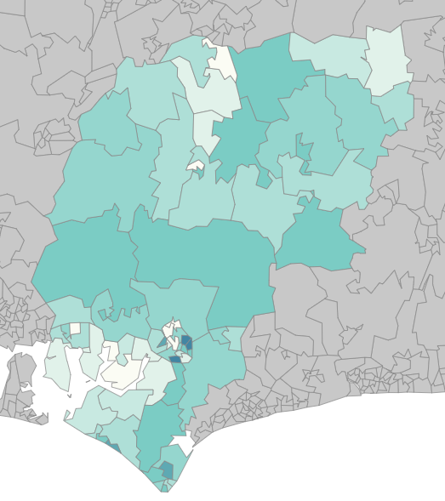

Least deprived area

Most deprived area

Chichester LSOAs map coloured by the IMD. Darker areas mean higher level of deprivation.

When analysing the most deprived area across the seven domains of deprivation, the area has scored poorly in Education ranked in the decile 2, Income, Employment and Health deprivation and disability have scored on the decile 3.

Looking across all the various domains of deprivation, it is clear that deprived areas in Chichester ranked poorly on barriers to housing and services and living environment. The areas ranked better on issues such as crime and employment.

# Prevalence

The following data will aim to describe the scale of drug activity in Chichester.

## **Drug Litter**

Chichester District Council cleansing team keeps the streets safe cleaning drug litter. When drug litter is found, the team keeps a log of the drug litter where specifies where the drug litter was found, the type of drug litter and quantity. Thanks to that we can have a better understanding of the level of drug activity in Chichester. This data will not provide a complete picture of the level of drug use on the community, not even all public drug use or drug litter finds.

For our analysis, we could have access to the drug litter records from 1st January 2020 to 31st August 2023, during this time 183 records of drug litter were logged by the cleansing team, 2021 was the year with the highest number of records, and the total number or records decreased year-on year from 2021 to 2023, by 49% from 2021 to 2022 and by 64% from 2022 up to 31st August 2023.

The number of drug litter records varied by month each year, although more records were logged in May June and August.

Figure 12: Drug litter records Chichester 2020 - 2023Source: Chichester District Council

The records also make reference of the type of drug litter found; Chichester cleansing team logs the drug litter using a 15 categories code and also they record the quantity they find.

Table 2: Drug litter records by type of drug litter 2020 – 2023

|  |  |  |  |  |  |  |  |  |
| --- | --- | --- | --- | --- | --- | --- | --- | --- |
|  | **2020** | | **2021** | | **2022** | | **2023** | |
| **Type of drug litter** | **Records** | **Quantity** | **Records** | **Quantity** | **Records** | **Quantity** | **Records** | **Quantity** |
| 1 - Drinks cans or foil containers, may be discoloured by heat |  |  | 1 | 1 |  |  |  |  |
| 2 - Spoons - burnt or discoloured by heat | 2 | 13 | 5 | 10 | 1 | 2 | 0 |  |
| 3 - Pipes, all shapes, sizes and materials |  |  |  |  |  |  |  |  |
| 4 - Cigarette papers or ripped packs |  |  |  |  |  |  |  |  |
| 5 - Foil with burn mark down the middle |  |  |  |  |  |  |  |  |
| 6 - Shredded cigarettes |  |  |  |  |  |  |  |  |
| 7 - Squares of papers (folded to form a small envelope) |  |  |  |  |  |  |  |  |
| 8 - Syringes, barrels and needles | 51 | 251 | 57 | 179 | 31 | 106 | 5 | 47 |
| 9 - Plastics bags, corners of plastic bags, small "Ziplock" bags | 3 | 4 | 8 | 11 | 5 | 33 |  |  |
| 10 - Aerosol cans, butane gas containers | 1 | 30 | 3 | 32 | 1 | 20 | 6 | 7 |
| 11 - Small phials and bottles | 1 | 20 | 1 | 2 |  |  |  |  |
| 12 - Small colourfully "branded" packets used to hold NPS |  |  |  |  |  |  | 1 | 2 |
| 13 - Small (harm reduction) foil water dishes used in preparing injections |  |  |  |  |  |  |  |  |
| 14 - Blister packs of over counter cold/flu - antihistamine capsules |  |  |  |  |  |  |  |  |
| **Grand Total** | **58** | **318** | **75** | **235** | **38** | **161** | **12** | **56** |

Source: Chichester District Council

The table above shows the number of times the cleaning team has found every type of drug litter and also the number of pieces found.

The main type of drug litter found is 8 (Syringes, barrels and needles), found in 78% of cases, 2020 was the year where more quantity was found and 2021 the year with more records. The second type of drug litter found (8.7% of cases) is 9 (Plastics bags, corners of plastic bags, small "Ziplock" bags), 2021 was the year with more findings recorded and no records in 2023. If we pay attention to the quantity recorded for each type of drug litter, type 10 (aerosol cans, butane gas containers) is the second drug litter with more quantity recorded.

Some types of drug litter were found in big quantities, could indicate that the drug referring to that type of litter could be consumed in big groups of people or is a hotspot area. As average, the cleansing team recorded eight aerosol cans, butane containers, every time they find this type of drug litter, while drug litter 8, the drug litter with more findings (Syringes, barrels and needles) was found, as average, in groups of four.

The majority of drug litter were recorded in Chichester Central ward especially from 2021 to 2022. The second and third wards with more records were Chichester South and Chichester East. In Chichester Central, many of the findings were in car parks and surrounding areas.

Figure 13: Drug litter records by wards 2020 – 2023Source: Chichester District Council

Figure 14: Drug litter records in Chichester 2020 – 2023 (Quantity)

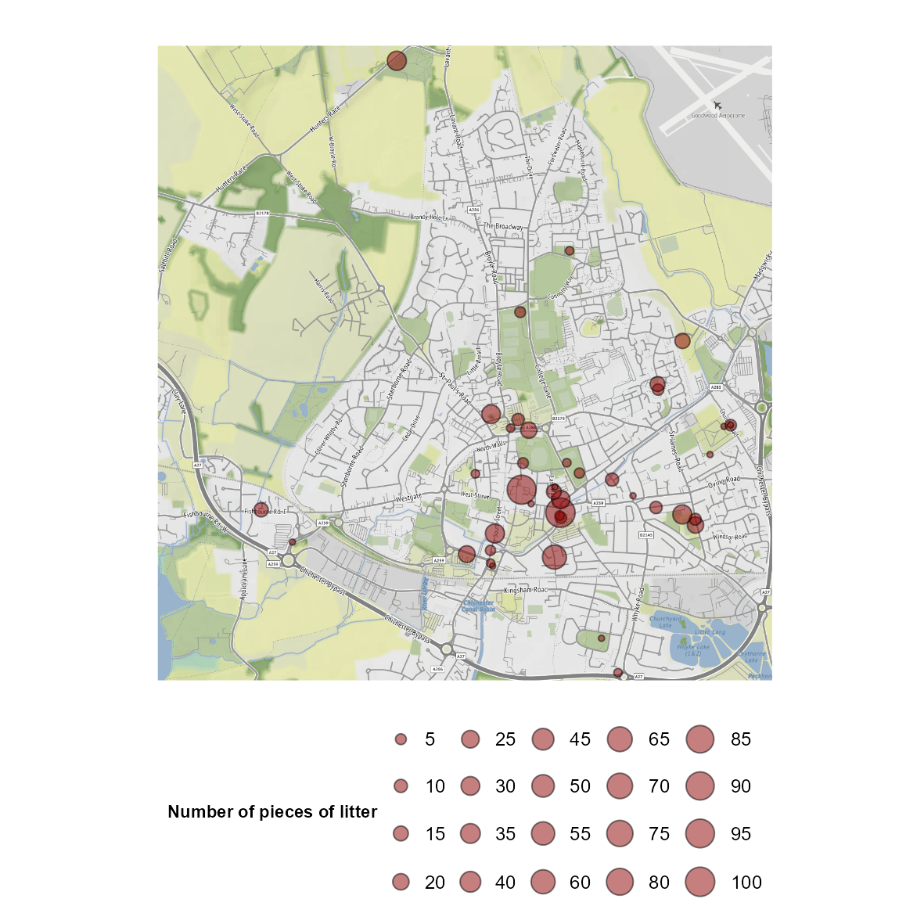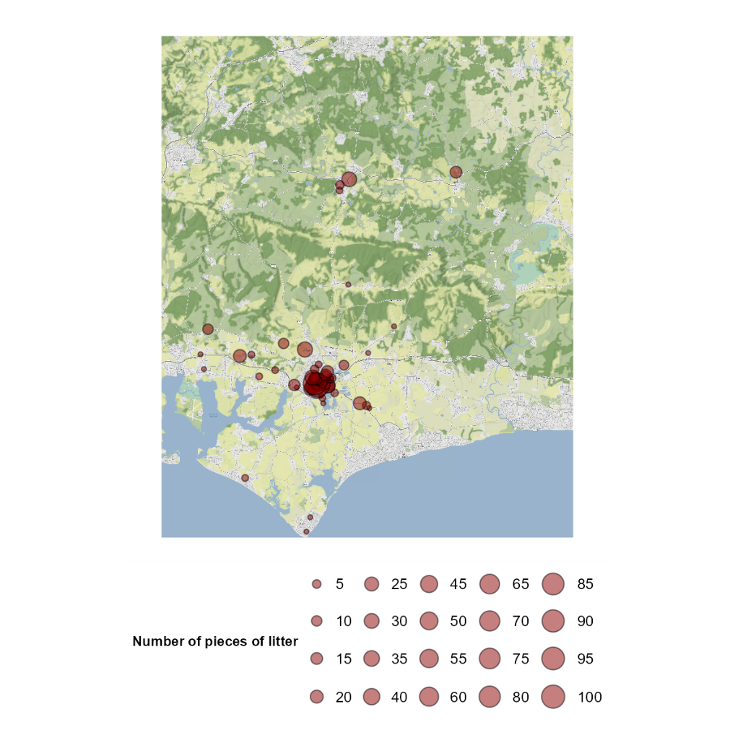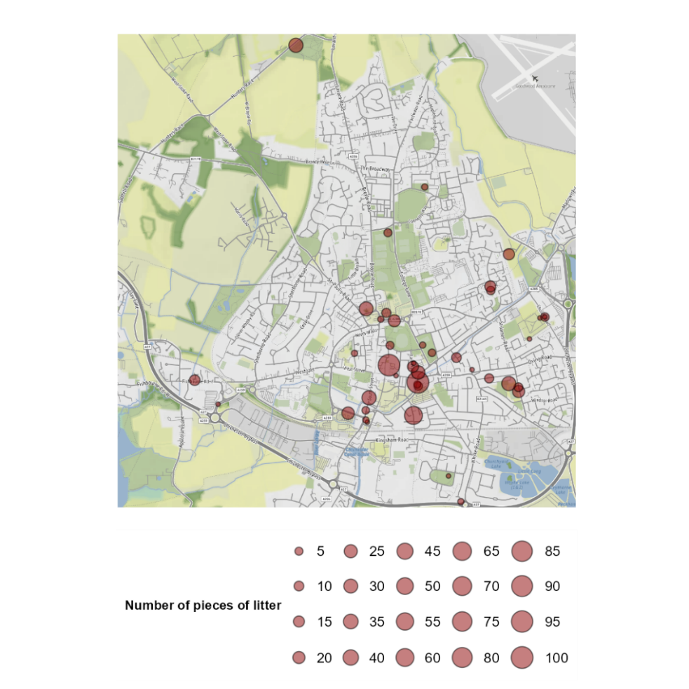

Source: Chichester District Council

## **Criminal activity and Drug offences**

Below we can find the drug related crime recorded by Sussex Police from January 2020 to December 2023 in Chichester. Chichester has been compared with other areas in West Sussex.

During the period analysed, there were 745 offences recorded as drug crime by Sussex Police. 2021 was the most active year, mainly due to the peak in February 2021; 2022 was the least active. The number of offences varies by month, as seen in the figure below.

*Figure 15: Offences recorded as “drug crime” by Sussex Police 2020-2023*

Source: data.police.uk/data/

The ward with the highest number of offences recorded as “drug crime” was Chichester Central.

*Figure 16: Offences recorded as “drug crime” by Wards 2020-2023*

Source: data.police.uk/data/

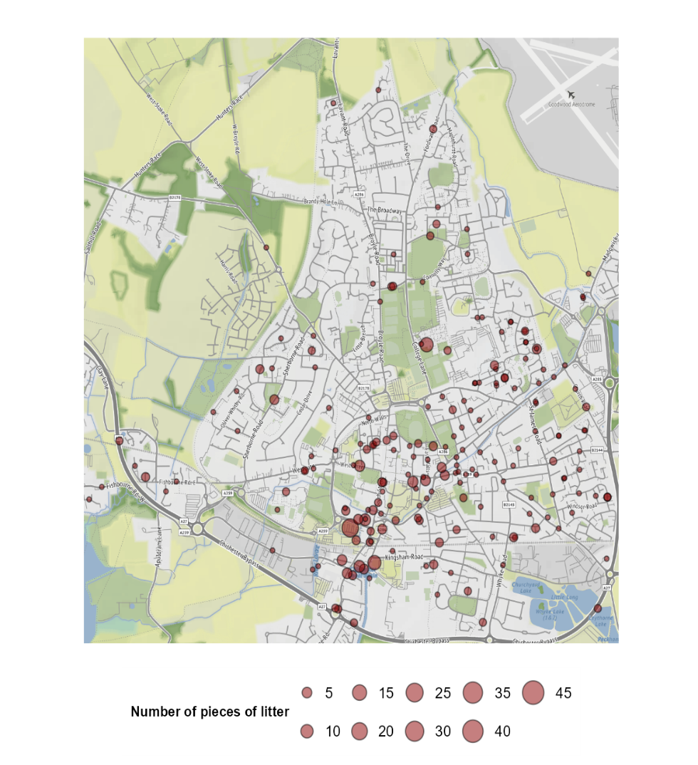*Figure 17: Map of offences recorded as “drug crime” by Sussex Police 2020-2023*

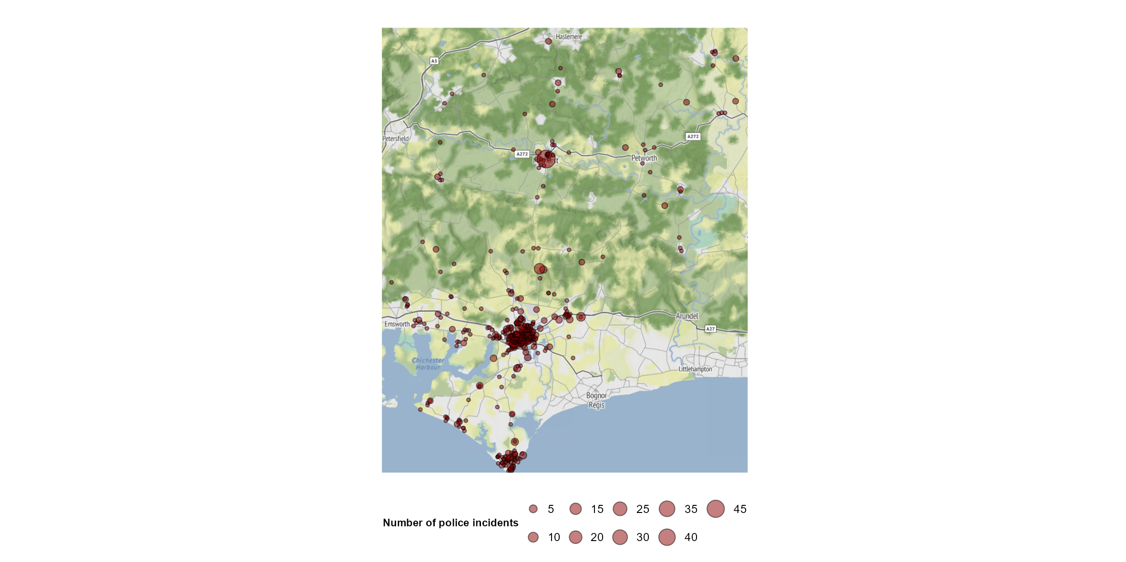



Source: data.police.uk/data/

If we compared the drug offences from Chichester with the rest of West Sussex, Chichester is the second area with less drug offences overall. Crawley stands out as the locality with the highest number of offences. It should be noted that higher levels could reflect specific local programmes and initiatives, such as the “Clear, Hold, Build” programme in Crawley.

*Figure 18: Drug offences – West Sussex 2020-2023*

Source: data.police.uk/data/

## **BRITISH TRANSPORT POLICE – Drug related incidents**

In addition to the information received by Sussex Police, it is helpful to understand drug related offences recorded by British Transport Police (BTP). Train lines are used to transport drugs, including as a method of transport used by county lines.

British Transport Police (BTP) have provided information of drug related incidents for the period 1st January 2020 to 31st December 2023.

Over the period analysed, BTP has 160 drug related incidents in West Sussex. 2022 was the year with more incidents, twice as many cases than 2021. From 2022 to 2023 drug incidents reduced by 20%. In this period, Chichester had 5 cases of which all of them has been in 2023.

Figure 19: BTP – Drug related incidents West Sussex 2020 - 2023Source: BTP

All the 5 incidents in Chichester have been recorded in Chichester Railway Station and 4 of the records are referring to Cannabis (in the form of resin, plant or sativa), the other case is unknown; similar to West Sussex where cannabis (and derivatives) represents 71% of incidents.

Offences – by Demographic Background

*Note : Due to small numbers for reasons of confidentiality, we have received the data for West Sussex overall and not by district and borough.*

By age, on the figure below, we can see how the younger people account for most of the drug incidents.

The age band under 19 gather most incidents over the period, 2022 was the year with more incidents (18) but 2021 the year with higher proportion (42%).

The age band 20 to 29 has the most incidents recorded in 2022 (25 incidents and 41% of incidents on that year).

Figure 20: BTP – Drug related incidents by age West Sussex 2020 - 2023

Source: BTP

By gender, males represent the 72.5% of all drug related incidents, females are the 12.5% and the rest are unknown. From 2022, despite the number of incidents for males increasing, the percentage of males on drug incidents are reducing due to females and unknown raising.

Figure 21: BTP – Drug related incidents by gender West Sussex 2020 - 2023

Source: BTP

Prevalence - Key points:

* From January 2020 to August 2023, 183 records of drug litter were logged by Chichester cleansing team, with a total of over 750 pieces of drug litter. Most drug litter were found in Chichester Central.
* Some types of drug litter were found in bigger quantity could indicate that this type of litter could be consumed in big groups of people or there is a hotspot area of drug use. As average, the cleansing team find eight aerosol cans, butane containers, every time they find this type of drug litter.
* Chichester is the second locality is West Sussex (after Crawley) with higher number of syringes, barrels and needles recorded.
* From January 2020 to December 2023 there were 745 offences recorded as drug crime by Sussex Police in Chichester. The ward with the highest number of offences recorded as “drug crime” was Chichester Central.
* British Transport Police recorded five drug related incidents in Chichester in 2023, (there were no records from 2020 to 2022). All incidents were recorded in Chichester Railway Station.
* Cannabis (and derivatives) were recorded in 4 incidents.
* Using data at a West Sussex level, we know that young males account for most incidents.

# Impacts in the community

## **Multiple disadvantage Audit**

A multiple disadvantages audit is completed each quarter by West Sussex housing support teams, the local housing authority as well as homelessness and housing service providers capture information about co-occurring needs alongside housing situation/ homelessness.

From April 2021 until December 2023, West Sussex housing support team received a total of 6,085 clients data returns from local housing authority, homelessness, and housing service providers. *(Note: Some clients would have been included in multiple quarterly reports, as they were still engaging with housing support services).*

In the table below we can see the data returns and of note, how many had substance misuse recorded as a need and how they compared to West Sussex.

*Table 3: Clients with substance misuse received by changing futures*

|  |  |  |  |  |  |  |  |
| --- | --- | --- | --- | --- | --- | --- | --- |
|  |  | **West Sussex** | | | **Chichester** | | |
|  |  | **Substance Misuse** | **%** | **Total Clients** | **Substance Misuse** | **%** | **Total Clients** |
| **2021** | **April - June** | 295 | 56.19% | 525 | 46 | 54.12% | 85 |
| **July - Sep** | 331 | 59.00% | 561 | 60 | 58.82% | 102 |
| **2022** | **Jan - Mar** | 410 | 70.93% | 578 | 96 | 92.31% | 104 |
| **April - June** | 386 | 59.57% | 648 | 89 | 52.05% | 171 |
| **July - Sep** | 385 | 61.60% | 625 | 71 | 50.00% | 142 |
| **Oct - Dec** | 191 | 61.02% | 313 | 4 | 66.67% | 6 |
| **2023** | **Jan - Mar** | 361 | 57.21% | 631 | 75 | 52.08% | 144 |
| **April - June** | 370 | 58.92% | 628 | 78 | 54.55% | 143 |
| **July - Sep** | 406 | 55.54% | 731 | 89 | 49.72% | 179 |
| **Oct - Dec** | 461 | 54.56% | 845 | 107 | 54.31% | 197 |
| **Grand Total** | | **3,596** | **59.10%** | **6085** | **715** | **56.17%** | **1,273** |

Source: Changing Futures

From the beginning of the programme, Chichester had very similar percentage of returns with substance misuse problem as West Sussex, surprising to see that one quarterly for Chichester over 90% of returns had substance misuse.

From all returns received by the programme, 76% are from males and 22% from females, with substance misuse, 80% are from males and 19% from females.

If we focus just on the clients with Substance misuse need identified, we can see that over the period, for West Sussex, the percentage of clients known to treatments services has been relatively stable and neither has improved the percentage of clients engaging with treatment. In Chichester, the percentage of clients engaging with treatment is lower than West Sussex despite the percentage known to treatment services is higher.

*Table 4: Clients with substance misuse received by changing futures known or engaged to treatment services*

|  |  |  |  |  |  |  |  |  |  |
| --- | --- | --- | --- | --- | --- | --- | --- | --- | --- |
|  |  | **West Sussex** | | | | **Chichester** | | | |
|  |  | **Substance Misuse** | **% Known to services** | **% Engaging with treatment** | **% Opiate substitution prescription** | **Substance Misuse** | **% Known to services** | **% Engaging with treatment** | **% Opiate substitution prescription** |
| **2021** | **April - June** | 295 | 0.00% | 35.93% | 20.00% | 46 | 82.61% | 30.43% | 21.74% |
| **July - Sep** | 331 | 0.00% | 39.88% | 22.36% | 60 | 90.00% | 35.00% | 28.33% |
| **2022** | **Jan - Mar** | 410 | 60.24% | 36.34% | 21.46% | 96 | 70.83% | 36.46% | 21.88% |
| **April - June** | 386 | 63.21% | 30.05% | 22.02% | 89 | 67.42% | 16.85% | 19.10% |
| **July - Sep** | 385 | 54.29% | 34.29% | 24.68% | 71 | 71.83% | 25.35% | 26.76% |
| **Oct - Dec** | 191 | 57.07% | 35.08% | 24.08% | 4 | 50.00% | 100.00% | 50.00% |
| **2023** | **Jan - Mar** | 361 | 50.42% | 34.90% | 22.44% | 75 | 66.67% | 26.67% | 26.67% |
| **April - June** | 370 | 51.35% | 35.95% | 21.35% | 78 | 70.51% | 28.21% | 28.21% |
| **July - Sep** | 406 | 68.23% | 33.50% | 20.94% | 89 | 75.28% | 31.46% | 25.84% |
| **Oct - Dec** | 461 | 63.77% | 31.02% | 19.31% | 107 | 70.09% | 26.17% | 23.36% |
| **Grand Total** | | 3596 | 58.99% | 34.48% | 21.72% | 715 | 72.73% | 28.67% | 24.62% |

Source: Changing Futures

86% of females with substance misuse in Chichester are known to treatment services, while for males the percentage drops to 70%, higher values than West Sussex (females 74.1% and males 61.8%). Of those known to treatment services in Chichester, 34% females engage on treatment and 40% of males, lower engaging rates than West Sussex, 52.5% for females and 54% for males.

**Multiple disadvantage**

In the graph below, we can see what other disadvantages people with housing problems and substance misuse are facing. Mental health issues were identified in 83% of returns of people with substance misuse, higher than West Sussex (76.8%). The second biggest issue identify was having a history of offending (52.7% of returns). Exploitation is affected on 13.3% of returns for Chichester, slightly lower than West Sussex, where exploitation is affected on 16.7% of returns (with substance misuse).

*Figure 22: Chichester returns with multiple needs*Source: Changing Futures

There was a total of 592 returns from clients with substance misuse and mental health problem, of those, just 22.5% of returns were having treatment for both issues at the same time, and 9.8% of returns are not getting any treatment for mental health or substance misuse.

60% of returns are from people who are in treatment just for one issue (54% treatment for mental health).

*Table 5: Chichester clients returns with substance misuse and mental health - treatment*

|  |  |  |  |  |  |  |
| --- | --- | --- | --- | --- | --- | --- |
| **Age** | **Mental health issues and Substance misuse** | **Just in Substance Misuse treatment** | **Just in Mental Health treatment** | **Both** | **Neither** | **Unknown MH or SM treatment** |
| **Under 18** | 3 | 0 | 2 | 0 | 1 |  |
| **18-24** | 42 | 0 | 31 | 1 | 7 | 3 |
| **25-40** | 223 | 13 | 115 | 49 | 24 | 22 |
| **41-60** | 298 | 23 | 157 | 76 | 23 | 19 |
| **61-79** | 22 | 0 | 11 | 6 | 3 | 2 |
| **Not recorded** | 4 | 0 | 3 | 1 | 0 | 4 |
| **Grand Total** | **592** | **36 (6%)** | **319 (54%)** | **133 (22.46%)** | **58 (9.79%)** | **46 (7.77%)** |

Source: Changing Futures

**Changing Futures**

Changing Futures is a programme carried out in Sussex with the objective of improving the lives of those experiencing multiple disadvantages in Sussex. Multiple disadvantage or multiple complex/compound needs is defined by the programme as people who experience three or more of:

* homelessness,
* current or historical offending,
* substance misuse,
* domestic abuse
* and mental ill health.

As of August 2024, there have been a total of 226 clients nominated for support from the Changing Futures Programme, and of those, 132 were accepted to received support, unfortunately we do not have the information by local area.

The most common combination of compounding needs for individuals accepted onto the Changing Futures caseload were Housing issues, Substance misuse, Mental health issues with histories of Offending behaviour and Domestic violence (27%).

*Table 6: Matrix of compounding needs for individuals accepted onto Changing Futures caseload Nov ’22 – Aug ‘24*

|  |  |  |  |  |  |  |
| --- | --- | --- | --- | --- | --- | --- |
| Mental Health issues | Domestic Violence | Substance Use issues | Offending Behaviour | Homelessness or Housing issues | Individuals | % of all referrals |
| MH | DV | SU | OB | HH | 36 | 27.3% |
| MH |  | SU |  | HH | 24 | 18.2% |
| MH |  | SU | OB | HH | 20 | 15.2% |
| MH | DV | SU |  | HH | 19 | 14.4% |
| MH | DV |  |  | HH | 12 | 9.1% |
| MH | DV | SU |  |  | 5 | 3.8% |
| MH | DV | SU | OB |  | 5 | 3.8% |
|  | DV | SU |  | HH | 3 | 2.3% |
| MH |  |  | OB | HH | <3 | n/a |
| MH | DV |  | OB | HH | <3 | n/a |
| MH |  |  |  | HH | <3 | n/a |
|  | DV | SU | OB | HH | <3 | n/a |
|  |  | SU | OB | HH | <3 | n/a |
|  | DV | SU |  |  | <3 | n/a |
| n = 126 | n = 84 | n = 115 | n = 67 | n = 121 | 132 | 100.0% |

Source: Changing Futures

95% of people who were accepted experienced poor mental health as a need at the time of nomination, 92% were experiencing homelessness, 87% had a substance use need, 64% were experiencing domestic violence and/or abuse and 51% of all clients nominated had current/historical contact with the criminal justice system.

## **Housing duties and support needs**

The Department for Levelling up, Housing and Communities (now the Ministry for Housing, Communities and Local Government) publish returns from local housing authorities (districts and boroughs) on the number of households owed a homelessness duty under the Homelessness Reduction Act 2017, this information can be further broken down by the support needs of households.

In Chichester in 2022/23 there were 372 households owed a duty. Of these, 182 were recorded as having support needs (49%). Drug dependency needs were recorded in 5% of these households.

*Table 7: Number of households owed a homelessness duty*

|  |  |
| --- | --- |
| **Total number of households assessed** | **2022-23** |
| Total households assessed as owed a duty | 372 |
| Total households with support need(s) owed a duty | 182 |
| Percentage of assessed households having support needs | 49% |
| (Total number of support needs for those owed a duty) | 277 |
| Drug dependency needs (%) | 10 (5%) |

Source: Department for Levelling Up, Housing & Communities

In the figure below we can see how drug dependency needs are the seventh highest need recorded in 2022/23.

Other needs recorded over the period were:

* history of mental health problems (41%),
* physical ill health disability (27%),
* at risk or history of domestic abuse (20%),
* history of offending (5%),
* alcohol dependency need (9%).

Overall, 122 households had one recorded need (67%), 35 households had two needs (19%), and 25 households had three or more needs (14%).

*Figure 23: Number of households owed a homelessness duty with support needs (11th most recorded needs)*Source: Department for Levelling Up, Housing & Communities

Compared to the rest of West Sussex, Chichester has the lowest percentage of assessed households having support needs in 2022/23.

*Table 8: Number of households owed a homelessness duty in West Sussex 2022/23.*

|  |  |  |  |  |  |  |  |
| --- | --- | --- | --- | --- | --- | --- | --- |
| Total number of households assessed | **Adur** | **Arun** | **Chichester** | **Crawley** | **Horsham** | **Mid Sussex** | **Worthing** |
| Total households assessed as owed a duty | 152 | 849 | 372 | 672 | 395 | 396 | 541 |
| Total households with support need(s) owed a duty | 113 | 460 | 182 | 395 | 199 | 220 | 387 |
| *Percentage of assessed households having support needs* | *74%* | *54%* | *49%* | *59%* | *50%* | *56%* | *72%* |

Source: Department for Levelling Up, Housing & Communities

## **Housing and homelessness support providers**

Between January 2020 and December 2023 Chichester District Council received 55 housing applications affected by drug dependency. Over the period analysed, from 2020 to 2022 applications remained stable but 2023 saw an increase of over 100% in the total of housing applications affected by drug dependency.

*Figure 24 : Number of housing applications affected by drug dependency needs 2020-2023*

Source: Chichester District Council

By gender, females represent 25% of all applications affected by drug dependency. In 2022, female applications affected by drug dependency were higher than male applications, in 2023 males’ applications affected by drug dependency increased four times compared to 2022.

*Figure 25: Number of housing applications affected by drug dependency needs 2020-2023 by gender*

Source: Chichester District Council

In the applications, was also recorded if the person had any other vulnerabilities that need additional support. In the table below are the percentages of housing applications affected by drug dependency and any other vulnerability. As well as having a drug dependency, 56% of housing applications are also affected by mental health problems. By gender, females are proportionally more likely be affected by mental health problems, domestic abuse and abuse/ exploitation while males are proportionally more likely to be affected by homelessness, offending history and alcohol dependency.

*Table 9: Percentage of housing applications affected by other vulnerabilities other than drug dependency 2020-2023 by gender*

|  |  |  |  |
| --- | --- | --- | --- |
| **Vulnerabilities** | **Female** | **Male** | **Grand Total** |
| Mental Health problems | 64.29% | 53.66% | 56.36% |
| Alcohol dependency | 35.71% | 43.90% | 41.82% |
| Homelessness | 14.29% | 36.59% | 30.91% |
| Offending History | 7.14% | 34.15% | 27.27% |
| Physical disability | 21.43% | 14.63% | 16.36% |
| Domestic Abuse | 35.71% | 2.44% | 10.91% |
| Abuse/ Exploitation | 21.43% | 7.32% | 10.91% |
| Learning disability | 0.00% | 7.32% | 5.45% |
| Care leaver | 0.00% | 4.88% | 3.64% |
| Access to education, employment or training | 0.00% | 4.88% | 3.64% |

Source: Chichester District Council

**Stonepillow** offers homelessness support services in Chichester, Bognor Regis and Littlehampton. From January 2020 to December 2023 they have supported around 700 people with historic or current drug or alcohol misuse. Alcohol and Cannabis were the substances most frequently mentioned, Alcohol was consumed by 37% of people and Cannabis by 31%.

By age group, cannabis is the main substance used from 18 until 34 years old, while people of age 35 to 44 the main substance was alcohol, at the age between 45 and 54 the amount of people consuming alcohol doubles cannabis.

*Figure 26: Substances currently consumed by service users when engaging with homelessness support provider*Source: Stonepillow

By gender, females were 22% of their service users and they were more affected by alcohol than males, 41% of females and 36% of males. Females were also more affected by crack use, 23% whilst males are 13%.

## **Employment and economic inactivity**

Job Centre Plus are responsible for managing claims and payment of Jobseeker's Allowance, Incapacity Benefit, Employment and Support Allowance and Income Support.

It is not currently possible to assess numbers of individuals with substance misuse or housing issues within the data, but unemployment and Job Centre Plus activity may be indicative of underlying vulnerabilities in the community.

As August 2023, Chichester had a total of 123 Job seeker’s allowance claimants, of which 31% were of the duration of 5 years and over.

*Table 10: Job seeker’s allowance claimants and duration of current claim (Aug 2023)*

|  |  |  |  |  |  |  |  |
| --- | --- | --- | --- | --- | --- | --- | --- |
| Duration of Current Claim | Up to 3 months | 3 months up to 6 months | 6 months up to 1 year | 1 year and up to 2 years | 2 years and up to 5 years | 5 years and over | All JSA claims |
| Adur | 43 | 8 | 8 | - | - | 29 | 81 |
| Arun | 98 | 25 | 25 | 6 | 18 | 40 | 205 |
| **Chichester** | **38** | **27** | **6** | **-** | **8** | **38** | **123** |
| Crawley | 80 | 22 | 12 | 6 | 14 | 54 | 186 |
| Horsham | 59 | 30 | 13 | 5 | 5 | 12 | 115 |
| Mid Sussex | 73 | 18 | 14 | 8 | 12 | 6 | 130 |
| Worthing | 48 | 16 | 7 | 6 | 5 | 30 | 111 |
| West Sussex | 439 | 146 | 85 | 31 | 62 | 200 | 951 |

Source: JCP Performance data

The Office for National Statistics estimate **local unemployment rates**, by examining the proportion of economically active people aged 16 years and over without a job, who have been actively seeking work within the last four weeks and are available to start work within the next two weeks.

Locally, unemployment has been running steady at four percent over the past several years, similar to the rest of West Sussex.

**Economic inactivity** is a measure of the proportion of people aged between 16 and 64 years who are not in employment but do not meet the internationally accepted definition of unemployment because they have not been seeking work within the last four weeks or they are unable to start work in the next two weeks.

Over the county, this typically ranged from between 15% to 25%. The Chichester inactivity rate has increased in recent years and in the last three year average 2020/22 was 29%, the highest rate in West Sussex.

*Figure 26: Economic inactivity rate (3 year rolling averages)*

Source: ONS data

## **Early Help**

Early Help is a service provided by WSCC designed to assess families with children under 18, the assessments are for the whole family and not for individual households, as it would also include parents not living with children in the same household. The objective of those assessments is to identify needs and offer support at the early stage before issues may escalate.

Between the 1st January 2020 and 31st December 2023 West Sussex received a total of 8,894 family assessments (initial assessments could have been done years before 2020) of those, 1,285 family assessments were affected by substance misuse (drug or alcohol) by parents, children or both.

The table below show the number of families receiving support from Early Help with substance misuse mentioned by adults or children, for Chichester and West Sussex by year (some families may have been receiving support for more than one year, so we have counted them every year they received support).

Table 11: Families receiving Early Help support by year

|  |  |  |  |  |  |  |  |  |
| --- | --- | --- | --- | --- | --- | --- | --- | --- |
|  |  | **Adult substance misuse mentioned** | | **Child substance misuse mentioned** | | **Adult AND Child substance misuse mentioned** | | **All CSC assessments** |
| **2020** | **Chichester** | 71 | 13.52% | 26 | 4.95% | 3 | 0.57% | 525 |
| **West Sussex** | 402 | 10.73% | 180 | 4.81% | 27 | 0.72% | 3743 |
| **2021** | **Chichester** | 42 | 11.20% | 20 | 5.33% | 4 | 1.07% | 375 |
| **West Sussex** | 360 | 11.41% | 151 | 4.79% | 26 | 0.82% | 3155 |
| **2022** | **Chichester** | 44 | 12.43% | 23 | 6.50% | 6 | 1.69% | 354 |
| **West Sussex** | 331 | 11.49% | 159 | 5.52% | 27 | 0.94% | 2882 |
| **2023** | **Chichester** | 46 | 11.7% | 18 | 4.58% | 2 | 0.51% | 393 |
| **West Sussex** | 321 | 11.64% | 162 | 5.87% | 20 | 0.73% | 2758 |

Source: Early Help

Overall, in Chichester both adult and children with substance misuse mentioned as part of an assessment have been decreasing over the period, both in terms of incidence and percentage of all assessments completed.

By ward, Chichester East had the highest number of support plans which mentioned both adult and children with substance misuse.

Figure 27: Families receiving Early Help support with Adult substance misuseSource: Early Help

Figure 28: Families receiving Early Help support with Children substance misuseSource: Early Help

With a new framework introduced in Oct 2022, Early Help assessments can also identify other needs facing families with adults or children affected by substance misuse, such as mental health needs (adult and children), homelessness (adults and young persons), adults in the family that are workless, young person NEET (not in education, employment or training). Unfortunately, for some of the needs (adult mental health and young person excluded or at risk of exclusion from the family home) could not be extracted from the old system for the period of interest.

We looked at how many early help assessments with children with substance misuse also identify a mental health problem. And as we can see in the figure below, most of the assessments identifying child substance misuse, also identify children with mental health problems.

Figure 29: Early Help assessments with children substance misuse and mental health problems and NEETSource: Early Help

From the early help assessments:

* 86.4% of children with substance misuse also suffer from Mental health problems, dropping to 66% when children don’t have substance misuse identified.
* 18.6% of children with substance misuse identified are also NEET
* while just 5.3% of children who don’t have substance misuse identified are also NEET.

In the figure below, the risk of homelessness was higher in households where substance misuse by adults was identified compared with households where no adult substance misuse was noted. 10.3% of households where adult substance misuse was noted were also at risk of being homeless, compared with 6.9% of households where substance misuse was not identified.

There was a greater difference observed in relation to worklessness. A higher percentage of workless families also had adult substance misuse (24.1%) compared with 14.5% of families where no adult substance misuse was recorded.

Figure 30: Early Help assessments with adult drug use and Family at risk of homeless and adult worklessSource: Early Help

Regarding adults’ mental health needs, if we just consider the new assessments from 2023, 73% of assessments with adult substance misuse mentioned also identify adult mental health needs, in the case of adults with no mention of substance misuse, mental health need drop to 60.5%.

## **Children’s Social Care**

As part of our research, we requested data from Children’s Social Care to obtain information for the period between January 2020 to December 2023 to know how many children were affected by parents using drugs and also, how many children were identified with drug use and their age. Each assessment is for one child, (e.g., if in a family there are three children affected by parents’ drug use, it would be three assessments, one for each child). Due to a change in the data recording system, we have focused on data for 2022 and 2023.

For the period analysed, Chichester has a total of 158 cases of parents with drug use and 29 cases of children using drugs. In total, they were 183 instances with parents and/or child drug use mentioned, 4 of those, with both parent and child with drug use. Over the period analysed, the incidents have increased specially by child drug use, from 0.6% in 2022 to 2.0% in 2023.

Table 12: Drug use mentioned on CSC assessments

|  |  |  |  |  |  |  |
| --- | --- | --- | --- | --- | --- | --- |
|  |  | **Parent drug use mentioned** | | **Child drug use mentioned** | | **All CSC assessments** |
| **2022** | **Chichester** | 75 | 6.9% | 7 | 0.6% | 1,085 |
| **West Sussex** | 600 | 6.0% | 176 | 1.7% | 10,067 |
| **2023** | **Chichester** | 83 | 7.7% | 22 | 2.0% | 1,082 |
| **West Sussex** | 613 | 6.6% | 222 | 2.4% | 9,254 |

Source: Children social care performance data

Table 13: Drug use mentioned on CSC assessments

|  |  |  |  |  |  |  |
| --- | --- | --- | --- | --- | --- | --- |
|  |  | **Parent AND/OR Child drug use mentioned** | | **Parent AND Child drug use mentioned** | | **All CSC assessments** |
| **2022** | **Chichester** | 81 | 7.5% | 1 | 0.1% | 1,085 |
| **West Sussex** | 743 | 7.4% | 33 | 0.3% | 10,067 |
| **2023** | **Chichester** | 102 | 9.4% | 3 | 0.3% | 1,082 |
| **West Sussex** | 785 | 8.5% | 50 | 0.5% | 9,254 |

Source: Children social care performance data

8.3% of 2,167 assessment in Chichester were identified with drug use, either by the parent, child or both, similar to 7.9% of 19,321 assessments for West Sussex.

By wards, if we analyse the data by number of assessments with parent and/or child drug use mentioned, Chichester North and Chichester South are the wards with the highest number of incidents, Chichester South in 2022 and Chichester North in 2023.

Figure 31: Parent AND/OR Child drug use mentioned by WardsSource: Children social care performance data

It is worth mentioning, that Fittleworth, despite having just 8 incidents with a parent and/or child drug use, 40% of CSC assessments are mentioned drug use by parent or child due to the small number of assessments received (compared to other areas).

Table 14: Parent AND/OR Child drug use mentioned by Wards

|  |  |  |  |
| --- | --- | --- | --- |
| **Wards** | **Count of parent and/or child drug use mentioned** | **% of all assessments** | **CSC Total assessments** |
| Chichester North | 20 | 10.9% | 183 |
| Chichester South | 20 | 10.0% | 200 |
| North Mundham & Tangmere | 15 | 7.9% | 191 |
| Chichester West | 14 | 8.4% | 166 |
| Chichester East | 13 | 8.4% | 154 |
| Westbourne | 13 | 16.7% | 78 |
| The Witterings | 11 | 8.5% | 129 |
| Petworth | 10 | 14.7% | 68 |
| Selsey South | 10 | 10.6% | 94 |
| Midhurst | 9 | 9.0% | 100 |
| Fittleworth | 8 | 40.0% | 20 |
| Sidlesham with Selsey North | 8 | 5.8% | 139 |
| Lavant | 6 | 10.3% | 58 |
| Harbour Villages | 5 | 3.5% | 144 |
| Southbourne | 5 | 4.6% | 109 |
| Goodwood | 4 | 4.3% | 94 |
| Harting | 4 | 11.4% | 35 |
| Loxwood | 4 | 4.7% | 85 |
| Fernhurst | 2 | 2.6% | 76 |
| Chichester Central | 1 | 4.0% | 25 |
| Easebourne | 1 | 5.3% | 19 |

Source: Children social care performance data

The next figure shows the age of children when the parent or child had drug uses mentioned in their CSC assessment, we can see how at the age of 14 the CSC assessments start to record an increase of incidents with child drug use.

To note the high number of assessments with adult drug use when children are under two years old.

*Figure 32: Age distribution of children in Chichester mentioning parent and/or child drug use (total values)*

Source: Children social care performance data

*Figure 33: Age distribution of children in Chichester mentioning parent and/or child drug use compared to West Sussex (% within each area)*

Source: Children social care performance data

As we can see in last figure, Chichester’s age distribution differs from West Sussex when the children are very young, as CSC assessments with parent drug use is higher than the average for West Sussex. Also, CSC assessments with child aged 14, 15, 16 and 17 are higher for West Sussex than Chichester, due to other areas being more affected by child drug use at these ages.

Some children are under the care of the local authority, known as Children We Care For or CWCF, 6% of CWCF in West Sussex for the full year preceding March 2023 had been identified as having a substance misuse issue. Most of these children with substance misuse issues identified do not accept the offer of further support. As we can see in the table below, Chichester had one child identified with substance misuse and did not accept support.

Table 15: Children We Care For (CWCF) for 12 months or more, as of 31st March 2023.

|  |  |  |  |  |  |  |  |  |
| --- | --- | --- | --- | --- | --- | --- | --- | --- |
|  | **Adur** | **Arun** | **Chichester** | **Crawley** | **Horsham** | **Mid Sussex** | **Worthing** | **West Sussex** |
| **All CWCF** | **37** | **75** | **32** | **60** | **25** | **33** | **105** | **367** |
| Identified with substance misuse | 1 | 5 | 1 | 4 | 0 | 0 | 12 | 23 |
| Intervention received | 0 | 0 | 0 | 3 | 0 | 0 | 5 | 8 |
| Offered but not accepted | 1 | 5 | 1 | 1 | 0 | 0 | 7 | 15 |
| % Children, identified with substance misuse | 2.7% | 6.7% | 3.1% | 6.7% | 0.0% | 0.0% | 11.4% | 6.3% |
| % Identified, who received intervention | 0% | 0% | 0% | 75% | n/a | n/a | 42% | 35% |
| % Identified, offered but not accepted | 100% | 100% | 100% | 25% | n/a | n/a | 58% | 65% |

Source: Children’s social care performance data

## **School exclusions and suspensions**

We have analysed drug and alcohol related school exclusions for the last 3 academic years (2021/22, 2022/23 and 2023/24 up to May 2024).

Note: Fixed period exclusions (up to 45 school days in a school year) are referred to as suspensions and when permanent we refer to them as exclusions.

In West Sussex, from 2021/2022 there have been over 1,200 episodes of drug and alcohol related suspensions in schools with a total of over 2,500 school days missed. In 2022/2023 academic year there was an increase of 50% on drug and alcohol related suspensions compared to the previous year. This increase was accounted for by, in the main, by exclusion of boys.

Figure 34: Drug and alcohol related school suspensions in West Sussex

Source: Children’s Services Data and Performance

Over the period analysed, Chichester had 119 episodes of drug and alcohol suspensions with a total loss of 239 school days and 3 exclusions. Females in Chichester represent a lower rate than the average for West Sussex (28% females in Chichester compared to 35% females in West Sussex).

Figure 35: Drug and alcohol related school suspensions by gender and academic year - Chichester

Source: Children’s Services Data and Performance

Chichester High School has the highest number of suspensions, especially for2021/22.

Figure 36: Drug and alcohol related school suspensions and in ChichesterSource: Children’s Services Data and Performance

If we have a look at the exclusions, Chichester has a total of three drug and alcohol related school exclusions, two of them were in 2023/2024 academic year and is one of the areas with less exclusions.

Figure 37: Drug and alcohol related school exclusions in West Sussex

Source: Children’s Services Data and Performance

## **CGL - Referrals from Education for Under 18s**

Young people can get referred to CGL services via their education setting. From financial year 2021/2022 to 2023/2024 CGL received 108 education referrals (in relation to drugs and alcohol) for under 18s in West Sussex.

In the figure below, we can see the distribution of the referrals across West Sussex by financial years.

Figure 38: Drug and alcohol CGL education referrals – Under 18’s

Source: CGL performance data

Chichester has the lower amount of education referrals in West Sussex.

During this period, the substances most mentioned in referrals have been cannabis and alcohol.

Cannabis is the main substance, mentioned in 78% of referrals.

Figure 39: Drug and alcohol CGL education referrals – main substanceSource: CGL performance data

68% of the total referrals had some kind of intervention. 18% of young people referred declined further intervention.

Figure 40: Drug and alcohol CGL education referrals – Interventions

Source: CGL performance data

## **Exploitation**

In July 2023 Multi Agency Child Exploitation (MACE) was introduced, prior that, only children open to CSC were included in the data set. Between July and December 2023, 145 children were triaged at local Multi Agency Child Exploitation (MACE) reviews.

Where the risk type was known:

* at least 64% of these children were Criminally Exploited (CCE),
* 22% were exploited sexually (CSE)
* and 14% were a victim of both criminal and sexual exploitation.

In 32% of cases the risk was unknown.

* Almost 75% of the exploited children were aged 14-16 years.
* Half of the cohort were children in need (CIN), 17% open to Early Help and 16% on a Children Protection Plan (CPP).
* 61% were boys, with data suggesting a gendered response to exploitation, as girls identified a higher risk of sexual exploitation and boys of criminal exploitation.

*Figure 41: Child exploitation in West Sussex by exploitation type (CCE, CSE or Both)*

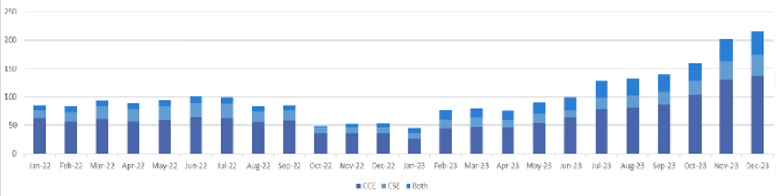

Source: West Sussex County Council Child Exploitation Team

## **Youth Justice Therapeutic and Family Interventions**

Children and young people identified by the WSCC Youth Justice Service receive focused interventions via the Therapeutic & Family Intervention Team to address underlying issues, to support a movement to a stable lifestyle and preparing young people for adulthood.

Some of the young people supported are also identified as having a substance misuse problem.

Service leads report that roughly 60% of the children and young people that they support have some level of drug or alcohol misuse issues which require interventions, data systems are being developed to capture these issues more consistently.

In West Sussex there were a total of 321 interventions cases closed in 2023/24 from 258 children (some children had more than one intervention). Of these, 40 individuals were recorded as having a substance misuse problem at the start of their intervention and 66 recording substance misuse at some point during their intervention. These were typically aged between 14 and 18 years by intervention end, though some were as young as 12 years. Roughly one third of these were female.

From the 24 interventions in Chichester, 29% were from individuals with substance misuse records, 21% with substance misuse recorded prior to start the intervention and 8% recorded at some point during the intervention.

*Table 16: Therapeutic & Family Intervention Team cases closed in 2023/24, by local geography*

|  |  |  |  |  |  |  |  |  |
| --- | --- | --- | --- | --- | --- | --- | --- | --- |
|  | Adur & Worthing | Arun | Chichester | Crawley | Horsham | Mid Sussex | Out Of County | **Total** |
| Substance misuse record starting **prior** to intervention | 9 | 11 | 5 | 8 | 1 | 1 | 5 | **40** |
| Substance misuse record starting **during** intervention | 23 | 15 | 2 | 10 | 5 | 5 | 6 | **66** |
| All interventions | 79 | 78 | 24 | 55 | 21 | 28 | 36 | **321** |

Source: Children Services Data & Performance Team

*Table 17: Therapeutic & Family Intervention Team cases closed in 2023/24, by age and substance need*

|  |  |  |  |
| --- | --- | --- | --- |
| Age of individual at end of intervention | Substance misuse record starting **prior** to intervention | Substance misuse record starting **during** intervention | All individuals supported |
| 10 years | 0 | 0 | 3 |
| 11 years | 0 | 0 | 1 |
| 12 years | 1 | 0 | 15 |
| 13 years | 0 | 2 | 35 |
| 14 years | 5 | 10 | 43 |
| 15 years | 8 | 17 | 65 |
| 16 years | 12 | 16 | 71 |
| 17 years | 8 | 14 | 60 |
| 18 years | 6 | 7 | 27 |
| 19 years | 0 | 0 | 1 |
| **Total** | **40** | **66** | **321** |

Source: Children Services Data & Performance Team

The majority of interventions lasted between 4-6 months, with 5% lasting up to a year or beyond.

Those young people who recorded substance misuse prior to, or during intervention tended to have longer intervention lengths than those without substance misuse reported, with nearly twice as many receiving their intervention for seven months or longer.

Of the 42 children and young people assessed for the substance misuse intervention programme, six were for alcohol only, and two more for alcohol and class A substances. Twenty-one were for cannabis use, with two more for cannabis and Xanax, and another one for cannabis and ‘polydrug use’.

*Table 18: Numbers of individuals in programme, by sex and main substance need (2023/24)*

|  |  |  |  |
| --- | --- | --- | --- |
| Substance need | Female | Male | All individuals |
| Alcohol only | 5 | 1 | 6 |
| Cannabis only |  | 21 | 21 |
| Alcohol and Cannabis | 1 | 9 | 10 |
| Alcohol and benzodiazepines |  | 1 | 1 |
| Alcohol, Crack and Heroin |  | 1 | 1 |
| Cannabis and Xanax |  | 2 | 2 |
| Cannabis and polydrug use |  | 1 | 1 |
| All substances | 6 | 36 | 42 |

Source: Youth Justice Intensive Interventions teams

Six were females, aged 13 to 17, and thirty-six were males, aged 13 to 18, with a peak around the age of 16. Of the twenty-one individuals who completed their full programme of support, five were entirely ‘drug-free’, and sixteen reported ‘occasional use’. Eleven of the twenty-one were deemed to need further support moving forwards, and ten needed no further support.

*Figure 42: Numbers of individuals in substance misuse programme, by sex and age (2023/24)*

Source: Youth Justice Intensive Interventions teams

Chichester has 3 males assessed by the programme.

*Table 19: Numbers of individuals in programme, by sex and district/borough (2023/24)*

|  |  |  |  |  |  |  |  |  |
| --- | --- | --- | --- | --- | --- | --- | --- | --- |
|  | Adur | Arun | Chichester | Crawley | Horsham | Mid Sussex | Worthing | West Sussex |
| Female |  | 1 |  | 1 | 2 |  | 2 | 6 |
| Male | 4 | 10 | 3 | 5 | 3 | 2 | 9 | 36 |

Source: Youth Justice Intensive Interventions teams

## **Probation Services**

The Probation Service is a statutory criminal justice service that supervises offenders serving community sentences or released into the community from prison. Their responsibilities are also to provide advice to courts on sentencing, deliver community payback and behavioural programmes, and provide information to victims of serious offences. They are responsible for sentence management in both England and Wales, along with Accredited Programmes, Unpaid Work, and Structured Interventions.

In West Sussex there are 3 geographical teams (based in Crawley, Littlehampton and Worthing) and 2 additional teams, 1 for Unpaid Work Standalone Orders (this are Orders where the only active requirement is Unpaid Work) and a team of Trainee Probation Officer (PQIP).

As of the 1st of February 2024, West Sussex probation teams were managing 1,319 Community and Licence Cases.

The table below shows the West Sussex Community and Licence Caseload, and the associated Offender Assessment System (OASys) needs identified.

As of the 1st of February 2024, West Sussex probation teams were managing 1,319 Community and Licence Cases.

Of the needs recorded “relationships” is the highest OASys Need (68%) among the caseload, followed by Lifestyle (61%). Drug needs account for 34% of the cohort, and alcohol 29%.

*Table 20: West Sussex – Probation Community/Licence Caseload with OASys Needs* *(Note people may have multiple needs recorded).*

|  |  |  |  |  |  |  |  |
| --- | --- | --- | --- | --- | --- | --- | --- |
| West Sussex Team | Crawley | Littlehampton | Worthing | PQIP | Unpaid Work Standalone | Total Community /Licence Caseload | % of OASys Need |
| Community/Licence Caseload | 555 | 436 | 246 | 74 | 8 | 1,319 | - |
| OASys Accommodation is a Need | 178 | 168 | 93 | 35 | 2 | 476 | 36.1% |
| OASys ETE is a Need | 166 | 166 | 89 | 26 | 1 | 448 | 34.0% |
| OASys Finance is a Need | 191 | 158 | 89 | 25 | - | 463 | 35.1% |
| OASys Relationships is a Need | 345 | 313 | 184 | 56 | 3 | 901 | 68.3% |
| OASys Lifestyle is a Need | 321 | 271 | 171 | 42 | 1 | 806 | 61.1% |
| **OASys Drugs is a Need** | **179** | **161** | **87** | **24** | **2** | **453** | **34.3%** |
| **OASys Alcohol is a Need** | **162** | **118** | **73** | **24** | **1** | **378** | **28.7%** |
| OASys Emotional Well-Being is a Need | 321 | 266 | 164 | 49 | 3 | 803 | 60.9% |
| OASys Thinking & Behaviour is a Need | 318 | 264 | 162 | 49 | 3 | 796 | 60.4% |
| OASys Attitudes is a Need | 282 | 250 | 136 | 43 | 3 | 714 | 54.1% |

Source: HM Prison and probation service – West Sussex performance data

The table below shows the Community sentences in West Sussex. Community sentences are alternatives to prison sentences and can carry requirements to engage in treatment or support services.

From January 2021 to January 2024 there were 149 Alcohol treatment Requirements, 118 Drug Rehabilitation Requirements, and 11 Mental Health Treatment Requirements. These have been imposed as alternatives to custodial sentences. Numbers have moderately increased over this time.

A new scheme in 2024 is to separate Mental Health Treatment Requirements into Primary Mental Health and Secondary Mental Health. Primary Mental Health will not require a formal diagnosis and is believed this will increase Treatment requirements for mental health needs in future.

*Table 21: West Sussex ATR/DRR/MHTR Sentences.*

|  |  |  |  |
| --- | --- | --- | --- |
| Sentence Year | Sentenced - Alcohol Treatment Requirement | Sentenced - Drug Rehabilitation Requirement | Sentenced – Mental Health Treatment Requirement |
| 2021 Total | 48 | 33 | 3 |
| 2022 Total | 40 | 35 | 3 |
| 2023 Total | 56 | 42 | 4 |
| 2024* January only | 5 | 8 | 1 |
| Total | 149 | 118 | 11 |

Source: HM Prison and probation service – West Sussex performance data

The table below shows the Commissioned Rehabilitative Service (CRS) referrals made between June 2021 (when CRS provision started) and 3rd February 2024. The majority of referrals were made by the Crawley team, and the highest number of referrals was for an Accommodation Service, followed by Personal Wellbeing.

*Table 22: West Sussex Commissioned Rehabilitative Service (CRS) Referrals (2021-24)*

|  |  |  |  |  |  |  |  |
| --- | --- | --- | --- | --- | --- | --- | --- |
| CRS Contract Type | Referral Year | Crawley | Littlehampton | Worthing | PQIP | UPW Standalone | Total CRS Referrals |
| Accommodation Service | Jun-Dec 2021 | 69 | 52 | 35 | 1 | 2 | 159 |
| Jan-Dec 2022 | 138 | 101 | 68 | 4 | 2 | 313 |
| Jan-Dec 2023 | 189 | 95 | 110 | 29 | - | 423 |
| Jan- 3rd Feb 2024 | 12 | 9 | 14 | 7 | - | 42 |
| **ACC Total** | | **408** | **257** | **227** | **41** | **4** | **937** |
| Dependency and Recovery Service | Jan-Dec 2022 | 29 | 25 | 7 | 2 | - | 63 |
| Jan-Dec 2023 | 147 | 67 | 53 | 10 | - | 277 |
| Jan- 3rd Feb 2024 | 16 | 8 | 5 | 3 | - | 32 |
| **D&R Total** | | **192** | **100** | **65** | **15** | **-** | **372** |
| Education, training and Employment | Jun-Dec 2021 | 38 | 29 | 20 | - | 2 | 89 |
| Jan-Dec 2022 | 75 | 67 | 30 | 4 | 3 | 179 |
| Jan-Dec 2023 | 81 | 41 | 38 | 17 | - | 177 |
| **ETE Total** | | **194** | **137** | **88** | **21** | **5** | **445** |
| Personal Wellbeing Service | Jun-Dec 2021 | 26 | 31 | 13 | - | - | 70 |
| Jan-Dec 2022 | 116 | 60 | 40 | 6 | 1 | 223 |
| Jan-Dec 2023 | 157 | 88 | 71 | 12 | - | 328 |
| Jan- 3rd Feb 2024 | 14 | 4 | 9 | 4 | - | 31 |
| **PWB Total** | | **313** | **183** | **133** | **22** | **1** | **652** |
| Women Services | Jun-Dec 2021 | 15 | 7 | 3 | 1 | - | 26 |
| Jan-Dec 2022 | 48 | 34 | 21 | 9 | 1 | 113 |
| Jan-Dec 2023 | 45 | 23 | 32 | 3 | - | 103 |
| Jan- 3rd Feb 2024 | 9 | 2 | 3 | 4 | - | 18 |
| **WOS Total** | | **117** | **66** | **59** | **17** | **1** | **260** |

Source: HM Prison and probation service – West Sussex performance data

## **CGL – People in structured treatment**

In West Sussex people who need treatment for their substance misuse can be referred, or can self-refer to CGL (Change, Grow, Live), the locally commissioned treatment provider.

Records of referral for structured treatment were provided by CGL for financial year 2020/2021 onwards and include different variables age, sex at birth, housing need, mental health need, employment status, drug category (as NDMTS[6]) and discharge time and reason.

In Chichester from 2020/2021 up to 2023/24 Q3 there were 1,015 people who received treatment from CGL. This includes 222 people who began treatment at some point during 2016/2017 to 2019/2020. Over the period analysed there were a total of 1,152 episodes.

* The number of people in treatment has been reducing year on year, for both, the total number of people but also the new triages.
* Total people in treatment has reduced in 22% if we compare 2022/23 with 2020/21,
* The number of new triages has reduced by 30% between 2022/23 and 2021/21.

Figure 42: Total individuals in treatment and new triages

Source: CGL performance data

From 2017/2018, getting alcohol treatment is the main reason to engage with CGL.

From 2017/18 the number of new triages due to “any opiates” is being very similar to “non-opiate and alcohol”. Non-opiate substance treatment has the lower number of new referrals.

Figure 43: Main substance treatment CGL referrals Source: CGL performance data

For the period analysed, self-referral is the most common referral source, 60% of total referrals, followed by Criminal Justice and GP/Hospital or health care provided with 12% each of total referrals.

Table 21: Referral source by year

|  |  |  |  |  |  |
| --- | --- | --- | --- | --- | --- |
| **Referral Source** | **2020/21** | **2021/22** | **2022/23** | **2023/24**  **Q 1,2,3** | **Grand Total** |
| Self | 191 | 125 | 119 | 117 | 552 |
| Criminal Justice | 35 | 42 | 22 | 13 | 112 |
| GP / Hospital / Health Care Provider | 30 | 28 | 32 | 20 | 110 |
| Other | 21 | 12 | 9 | 1 | 43 |
| Other treatment provider | 8 | 7 | 11 | 8 | 34 |
| Housing/homelessness service | 7 | 9 | 11 | 4 | 31 |
| Social Services | 2 | 9 | 5 | 1 | 17 |
| Relative/peer/ concerned other | 4 | 2 | 5 | 5 | 16 |
| Outreach | 3 | 1 | 1 |  | 5 |
| Domestic abuse service |  | 1 | 1 |  | 2 |
| Employment/education service |  |  | 1 |  | 1 |
| Adult mental health services |  |  |  |  | 0 |
| Adult social care services |  |  |  |  | 0 |
| Children and family services |  |  |  |  | 0 |
| **Grand Total** | **301** | **236** | **217** | **169** | **923** |

Source: CGL performance data

The number of successful completions is decreasing in recent years, in 2020/21 the number of successful completions were the reason for discharge in 44% of cases, in 2022/23, the rate of successful completion was 32% of total discharges.

Table 22: Discharges by year

|  |  |  |  |  |  |
| --- | --- | --- | --- | --- | --- |
| **Discharge reason** | **2020/21** | **2021/22** | **2022/23** | **2023/24 Q1,2,3** | **Grand Total** |
| Client Died | 5 | 4 | 3 | 2 | 14 |
| Dropped out - disengaged | 150 | 134 | 126 | 107 | 517 |
| Open to structured treatment | 9 | 7 | 9 | 20 | 45 |
| Retained in prison | 6 | 4 | 2 |  | 12 |
| Successful completion | 136 | 103 | 71 | 42 | 352 |
| Transferred to another service | 9 | 7 | 6 | 4 | 26 |
| Transferred to prison |  | 11 | 8 | 4 | 23 |
| Treatment declined |  | 1 | 2 | 1 | 4 |
| **Grand Total** | **306** | **264** | **218** | **160** | **948** |

Source: CGL performance data

From 2020/21 until 2023/24 (Q1,2,3), females represent the 34% of the total referrals.

If we have a look at the main substance they need treatment for, females are proportionally more likely to be seeking help for alcohol misuse (62% of females affected by alcohol alone compared with 43% of males).

The second category females need treatment for is “non-opiate and alcohol” and “any opiate” whilst males is “any opiates”.

Table 23: Main substance by gender

|  |  |  |  |  |
| --- | --- | --- | --- | --- |
| **Gender** | **Alcohol** | **Any Opiate** | **Non – Opiate** | **Non – Opiate and Alcohol** |
| Female | 332 | 89 | 46 | 79 |
| Male | 425 | 268 | 107 | 205 |
| Grand total | 757 | 357 | 153 | 284 |

Source: CGL performance data

By age, we can see how all the age bands have reduced the number of new referrals in similar ways, the age band 35-44 is the only age band that has increase new referrals in the first three quarterlies of 2023/24.

Figure 44: CGL referrals by age group

Source: CGL performance data

If we look by age group at the main substance they need treatment for, we see how individuals seeking alcohol treatment increases with the age and non-opiate and alcohol decreases with age. More people are seeking non-opiate treatment between the ages of 25-34, whereas more people are seeking opiate treatment between the ages of 35 and 54.

Figure 45: CGL referrals – main substance treatment (we have not represented 18-24 due to very low numbers)Source: CGL performance data

Multiple needs

* 19% of new referrals to CGL from 2020/21 to 2023/24 (Q3) have a housing problem, experience homelessness or are living in temporary accommodation. The age band most affected by housing needs is 35-44 years old, 24% would not have settled accommodation.
* 75% of people referred to CGL over the period analysed, were recorded as having mental health issues. Of those, 80% were engaging with some support to address their mental health issues, leaving 20% with mental health needs but not treatment, 3% of them would have declined treatment.
* 37% of new referrals over the period analysed were from people unemployed, of those, 73% were not looking for employment.

## **Naloxone provisions**

Naloxone is a medicine that can rapidly reverse the effects of an overdose due to opioids. Its provision in the community is an essential programme to prevent deaths of those vulnerable to substance overdoses. Since 2020/21 the rollout has increased significantly, and naloxone provision has nearly tripled between 2022/23 and 2023/24 (to Dec 2023) partly due to issuing additional kits to high-risk users in light of the contaminated opiate supply.

*Table 24: Naloxone kits dispensed in the community (including replacements for used, lost and expired kits. 2023-24 includes the supply of Naloxone and Nyxoid).*

|  |  |  |  |  |  |  |
| --- | --- | --- | --- | --- | --- | --- |
| **Naloxone provision** | **2019-20** | **2020-21** | **2021-22** | **2022-23** | **2023-24 Dec** | **Total** |
| Adur | 12 | 19 | 19 | 29 | 42 | 121 |
| Arun | 80 | 99 | 105 | 118 | 208 | 610 |
| Chichester | 48 | 74 | 69 | 56 | 121 | 368 |
| Crawley | 73 | 99 | 96 | 112 | 179 | 559 |
| Horsham | 42 | 39 | 27 | 35 | 72 | 215 |
| Mid Sussex | 35 | 31 | 35 | 28 | 79 | 208 |
| Worthing | 86 | 113 | 82 | 103 | 172 | 556 |
| Pharmacies | 17 | 26 | 25 | 17 | 84 | 169 |
| Naloxone Project | 0 | 46 | 186 | 218 | 881 | 1,331 |
| West Sussex HARP | 0 | 17 | 0 | 0 | 0 | 17 |
| **Total Issued** | **393** | **563** | **644** | **716** | **1,838** | **4,154** |

Source: CGL performance data

From 2019-20, service users in Chichester have received 368 Naloxone kits and the distribution in the last year has increased significantly.

Impacts in the community – Key points:

* From April 2021 to December 2023, the multiple disadvantage audit shows that the percentage of returns from people in Chichester experiencing housing problems with substance misuse was very similar to West Sussex.
* In Chichester, despite the percentage of clients known to treatment services is higher than West Sussex, the percentage of clients engaging with treatment is lower. Of those known to treatment services in Chichester, 34% females engage on treatment and 40% of males, lower engaging rates than West Sussex, 52.5% for females and 54% for males.
* In Chichester, 83% of returns from people with housing problems and substance misuse are also affected by mental health issues as shown in the multiple disadvantage audit (higher than West Sussex (77%), and 22% of them will be in treatment for both conditions at the same time.
* In Chichester there were 372 households owed a homelessness in 2022/23. Of these, 182 were recorded as having support needs (49%). Drug dependency needs were recorded in 5% of these households over the period, the lowest percentage in West Sussex. Drug dependency needs are the seventh most common needs recorded.
* Between January 2020 and December 2023 Chichester District Council received a total of 55 housing applications affected by drug dependency. Over the period analysed, from 2020 to 2022 applications remained stable but 2023 saw an increase of over 100% in the total of housing applications affected by drug dependency.
* 56% of housing applications with drug dependency are also affected by mental health problems.
* Stonepillow offers support to homeless individuals in Bognor Regis and Chichester. From January 2020 and December 2023, Alcohol and Cannabis were the substances more frequently mentioned, Alcohol was currently consumed by 37% of people and Cannabis by 31%.
* By age group, from 18 until 34 the main substance consumed is Cannabis and then at age 35 – 44 is alcohol and by age 45 – 54 the amount of people consuming alcohol doubles cannabis.
* In Chichester 31% of JSA claims are of the duration of 5 years and over, the highest percentage in West Sussex. The level on unemployment has been steady for the last few years at 4%.
* The rate of economically inactive population has been increasing in the last few years and in 2020/22 was 29%, the higher rate in West Sussex. However, it is not currently possible to assess numbers of individuals with substance misuse.
* Each year, around 17% of families receiving Early Help support are affected by substance misuse by parents, children or both. By ward, Chichester East had the highest number of support plans which mentioned both adult and children with substance misuse.
* 86% of children receiving Early help support with substance misuse use also suffer from mental health problems, mental health problems when children are not using drugs is 66%.
* 18.6% of children receiving Early Help support with substance misuse identified as a problem were not in education, employment or training (NEET), compared with a NEET rate of 5.3% when substance misuse is not recorded.
* 10.3% of families where substance misuse was identified as a problem in adults, are at risk of homelessness, compared to 6.9% when substance misuse is not mentioned.
* 24.1% of families where substance misuse was identified as a problem in adults, were also impacted by worklessness, compared to 14.5% when substance misuse is not mentioned.
* In 2023, 73% of Early help assessments with adult with substance misuse mentioned, also identify an adult mental health need, in the case of adults with no substance misuse mentioned, mental health needs drop to 60.5%.
* 8.3% of CSC assessments in Chichester were identified with drug use in the assessment, Chichester South and Chichester North were the areas with higher number of incidents, Chichester South in 2022 and Chichester North in 2023.
* Percentage of parents with drug use is higher in Chichester than the average for West Sussex when children are very young.
* In the last three academic years, Chichester had 119 drug and alcohol related suspensions, 2023/24 is the year with less episodes.
* The data available showed that the school with highest number of drug and alcohol related suspensions was Chichester High School. Chichester is one of the localities with lower number of exclusions over the period (3 exclusions).
* CGL education referrals (under 18) have kept stable from 2021/22 to 2023/24 and Chichester has the lower amount of education referrals in West Sussex. For West Sussex, cannabis has been the main reason to get referred to CGL.
* Chichester received 24 interventions from Youth Justice Therapeutic and Family intervention of which 29% were from individuals with substance misuse records, 21% with substance misuse recorded prior to start the intervention and 8% recorded at some point during the intervention.
* As of the 1st of February 2024, West Sussex probation teams were managing 1,319 Community and Licence Cases. Additional needs relating to drugs account for 34% of the cohort, and 29% for alcohol.
* In West Sussex, from January 2021 to January 2024, 149 Alcohol treatment Requirements, 118 Drug Rehabilitation Requirements, and 11 Mental Health Treatment Requirements have been imposed as alternatives to custodial sentences, and numbers have moderately increased over this time.
* The number of adults referred to CGL for treatment has been increasing from 2020/21, alcohol is the main referral reason, “any opiates” is the second substance driving referrals in 2022/23, in the first three quarterlies of 2023/24, the amount of referrals for “any opiate”, “non-opiate” and “no-opiate and alcohol” are very similar.
* Self-referral is the main referral source to contact CGL in 60% of cases.
* Females are, proportionally, more affected by alcohol than males (62% of females affected by alcohol alone compared to 43% of males).
* Relatively more people seek non-opiate drug treatment between the ages of 25-34, which reduces with age, whereas relatively more people seek opiate treatment between the ages of 35-54.
* 75% of new referrals made to CGL are from people who has a mental health problem. 19% will have a housing problem and 37% from people with an unemployment situation.
* Chichester has received 368 Naloxone kits and the distribution in the last couple of years has increased significantly.

# Impacts on health

## **Accident and Emergency attendances**

To understand the impact of drug use on health we requested local hospitals to provide data from 2020 to 2023.

For the four-year period, there were a total of 769 A&E attendances where drug use was recorded from people living in post codes[7] related to Chichester.

2020 was the year with the highest number of attendances and year-on-year attendances have been reducing and in 2023 attendances were 64% of what it was in 2020. By month, the number of attendances varied for each year, but February, August and October have more A&E attendances.

*Figure 46: A&E Attendances from people living in Chichester related post code where illicit drug was recorded.* Source: University Hospitals Sussex NHSFT

A&E attendances by females are higher than males over the period (57%), but females’ attendances have been reducing year-on-year and in 2023 were no difference between females and males. Males attendances haven not change since 2021.

*Figure 47: A&E Attendances by gender*

Source: University Hospitals Sussex NHSFT

The age groups with the highest attendance in 2020 were 16-24 and 25-34, but both age bands have been reducing the number of attendances and while the group 16-24 is still the one with more attendances the difference has reduced. The group 25-34 has similar values as other age groups in 2023.

*Figure 48: A&E attendances by age bracket. (*attendances under 9 have not been consider for our analysis)*Source: University Hospitals Sussex NHSFT

Females have bigger proportion of A&E attendances in the age brackets 9-15 (81%), 16-24 (65%) and Over 65 (68%) while males in the age bracket 25-34 represent 62% of attendances. The rest of age brackets they have similar attendance rate by gender.

*Figure 49: A&E attendances by age bracket and gender (*attendances under 9 have not been consider for our analysis)*Source: University Hospitals Sussex NHSFT

Unfortunately, we could not access the full post code so ward level analysis is not possible.

Over the period analysed, the post code PO19 (which refer mainly to wards: Chichester Central, Chichester North, South, East and West) had the highest number of attendances with 44% of A&E attendances.

The second post code with higher rate (24%) is PO20 (wards: Selsey South, Sidlesham with Selsey North, The witterings, North Mundham and Tangmere) and the one with less attendances is GU30 (Fernhurst) with just 2 attendances over the period.

Most post codes have reduced the number of attendances in 2023 compared to 2020.

*Figure 50: A&E attendances by post code and year (*attendances under 9 have not been consider for our analysis; due to small values of post codes: GU27, GU30 and GU31 were not include them in the figure)*Source: University Hospitals Sussex NHSFT

The type of drug was recorded as unknown/other for over 70% of attendances. In total there were 24 substances mentioned in A&E reports; the most known drugs with 45 and 42 attendances were Cannabis (5.8%) and Cocaine (5.5%). The third known drug was Benzodiazepine with 21 attendances (2.7%).

By Post code, in PO19, the drug with more mentions in A&E was Cannabis (21) followed by Cocaine (20). Heroin was just mentioned in PO19 and PO20.

PO20 and PO19 were the post code with the highest variety on substances recorded.

Excluding “unknown drug” records, by age, most of A&E attendances with Cannabis recorded is for the age bracket 16-24. Cocaine records were often recorded in the age bracket 16-24 and 25-34. The group 25-34 double the cases of Cocaine compared to Cannabis.

39% of attendances with heroin recorded have been on the age group 35-44 and 33% in the age bracket 45-54. One third of reports mentioning Benzodiazepine is in the age bracket 25-34.

The most recorded substance for over 65 has been Other opiate drugs. Other CNS depressants/ sleep-inducing drugs has been most mentioned in the age brackets 16-24 and 25-34.

*Figure 52: A&E attendances by type of drug and age (*attendances under 9 have not been consider for our analysis)*Source: University Hospitals Sussex NHSFT

The biggest difference on attendances by type of drugs and gender is that 87% of cannabis and 71% of cocaine attendances were from males. Females had higher proportion on mentions of Codeine (87%), Other CNS depressant / sleep-inducing drugs (74%), Ecstasy (MDMA) (71%) and Benzodiazepine (62%).

*Figure 53: A&E attendances by type of drug and gender (*attendances under 9 have not been consider for our analysis)*Source: University Hospitals Sussex NHSFT

The number of incidences of A&E attendances that end up in hospital admissions has decreased over the period, in 2020 51% of A&E attendances resulted in hospital admission, while in 2023 is 32%. In 2020 60% of females attending A&E would be admitted to hospital, while for males was 40%. In 2023, the gap between gender was reduced and in 2023 both are around 30%.

*Figure 54: A&E attendances and hospital admissions by gender (*attendances under 9 have not been consider for our analysis)*

Source: University Hospitals Sussex NHSFT

If we compare the A&E attendances from people living in Chichester with the rest of West Sussex over the period analysed, Chichester had 620 A&E attendances per 100,000 population, better than Crawley, Arun and Worthing.

*Figure 55: A&E attendances by locality (*attendances under 9 have not been consider for our analysis)*

Source: University Hospital Sussex and Surrey and Sussex Healthcare

*Figure 56: A&E attendances 2020-2023 rate per 100,000 population (*attendances under 9 have not been consider for our analysis)*

Source: University Hospital Sussex and Surrey and Sussex Healthcare

## **Ambulance attendances**

As part of our analysis and to understand the health impacts of drug use we have asked SECAMB (South East Coast Ambulance Service) for the ambulance attendances due to drug use in the area from January 2020 to December 2023.

Counts include all substance related incidents, not just illegal substances, since the drug cannot always be reliably determined.

During the period analysed (Jan 2020 to Dec 2023), Chichester had a total of 947 drug related ambulance attendances. There were more attendances to females compared with males. (except 2022 where males were slightly higher). In 2020 females drug incidents were 65%, since then, ambulance incidents have been dropping until 2022 due to females attendances reduction while males attendances have been increasing closing the gap between gender. In 2023 ambulance incidents increased by 40% compared to 2022; females increased by 50% while males increased by 32%.

*Figure 57: Ambulance attendances due to drug use 2020-2023 by gender*

Source: SECAMB

By age, over the period the age band 25-44 has the highest number of ambulance attendances.

The second age band with the highest number of incidents is 16 – 24.

In 2023 the group 65 and older has increased over 66% the number of incidences.

The age band under 15 has increased the number of ambulance attendances in the last couple of years, in 2020 and 2021 SECAMB could not share the counts for being under 10 but in 2020 counts were 10 and 15 in 2023.

*Figure 58: Ambulance attendances 2020-2023 by age* Source: SECAMB

Naloxone usage - Ambulance services use Naloxone in opiates drug incidences to rapidly reverse the effects of an opioid overdose. Due to the small count in Chichester, they were not able to provide how many times they have used it.

If we compare Chichester with the rest of West Sussex, Chichester has similar values to Horsham and Mid Sussex in incidences and when looking at rates per 100,000 population. In Chichester, like the rest of West Sussex, females attendances were higher than males (55% - 62%).

*Figure 59: Ambulance attendances due to drug use 2020-2023 in West Sussex*Source: SECAMB

*Figure 60: Ambulance attendances 2020-2023 rate per 100,000 population*  Source: SECAMB

## **Deaths related to substance misuse**

Each year the Office for Nationals Statistics (ONS) releases information on the number of deaths related to drug misuse by local authority. For the three years 2020 – 2022 there were 11 substance misuse related deaths in Chichester

*Table 25: Substance misuse deaths related – West Sussex 2020-2022*

|  |  |  |  |  |  |
| --- | --- | --- | --- | --- | --- |
|  | **2020** | **2021** | **2022** | **Grand Total** | **Rate per 100,000 population** |
| Adur | 1 | 2 | 1 | 4 | N/a |
| Arun | 3 | 4 | 8 | 15 | 3.2 |
| Chichester | 7 | 2 | 2 | 11 | 3.2 |
| Crawley | 6 | 1 | 3 | 10 | 2.9 |
| Horsham | 3 | 4 | 3 | 10 | 2.5 |
| Mid Sussex | 1 | 1 | 8 | 10 | 2.3 |
| Worthing | 1 | 4 | 5 | 10 | 3.2 |
| **West Sussex** | **22** | **18** | **30** | **70** | **2.8** |
| **(SOUTH EAST)** | **354** | **364** | **402** | **1,120** | **4.1** |
| **(ENGLAND)** | **2,830** | **2,846** | **2,906** | **8,582** | **5.2** |

Source: ONS

Given the relatively small number of deaths at a local authority level deaths over a three year period are compared. For the past two periods, West Sussex has had significantly fewer deaths from substance misuse (per 100,000) than the South East and England).

* The overall decrease in West Sussex is attributable to males, with rates of 5.1 deaths per 100,000 residents in 2017-19 falling to 3.5 deaths per 100,000 in 2020-22.
* Rates for females, whilst lower overall, have been slowly rising at 1.8 deaths per 100,000 in 2017-19 to 2.1 deaths per 100,000 in 2020-22.

Impacts in the community – Key points:

* Between January 2020 and December 2023, there were 769 A&E attendances where illicit drugs were recorded by people living in Chichester. 2020 was the year with the higher number of attendances and year-on-year attendances has been reducing and in 2023 attendances were 64% of what it was in 2020.
* A&E attendances by females were higher than males over the period (57%), but females attendances has been reducing year-on-year and in 2023 were the same as males.
* 44%% of A&E attendances were from people living in the post code PO19 (which refer to wards: Chichester Central, Chichester North, South, East and West).
* The type of drug was recorded as “unknown/other” for over 70% of attendances. Where recorded, and in total, 24 substances were mentioned in A&E reports the most frequently mentioned drug with 45 attendances (5.8%) was cannabis, cocaine was second with 42 attendances (5.5%).
* The main substances recorded in A&E attendances from people living in PO19 were cannabis, cocaine and heroin, PO19 is the post code with higher variety of substances.
* Most of A&E attendances with cannabis recorded were for the age bracket 16-24. Cocaine was mostly recorded in 16-24 and 25-34 age brackets and heroin was mostly recorded on the age brackets 25-44 and 45-54.
* The biggest difference on attendances by type of drugs and gender is that 87% of cannabis and 71% of cocaine attendances were from males. Females had higher proportion on mentions of Other CNS depressant / sleep-inducing drugs (74%), Ecstasy (MDMA) (71%) and Benzodiazepine (62%).
* In 2020, 51% of A&E attendances end up in hospital admission, this rate has been decreasing and in 2023 32% of A&E attendances resulted in hospital admission.
* From 2020 to 2023 SECAMB had 947 drug related attendances in Chichester, 2023 has been the year with the highest number of ambulance attendances. In 2020 female attendances were higher than male but over the period, the gap has reduced and in 2023 they have similar ambulance attendances rates.
* All age bands have increased the number of ambulance attendances in 2023 due to an overall increase in attendances, but the age band 65 and older has increased over 66% the number of incidents.
* If we compare Chichester with the rest of West Sussex, Chichester has similar values to Horsham and Mid Sussex in incidences and when looking at rates per 100,000 population.
* From 2020 to 2022 there were 11 substance misuse related deaths, similar to other local authorities in West Sussex.

# Community engagement

As part of our report and to understand the issues the community is facing regarding drug use and related harms, four surveys were developed targeting different parts of the community; residents, professionals and volunteers working with people affected by drug use and people in treatment.

Surveys for residents and professionals were available to be completed for 8 weeks during April and May and CGL service users survey was available for 6 weeks in April and May.

All surveys were available through a link provided for each target audience. The residents’ survey link was shared in West Sussex County Council social media platforms and Social Media channels used by Chichester District Council. The professionals survey link was shared directly with targeted professionals identified by the working group and also in a West Sussex County Council internal newsletter. The CGL Service users survey was shared internally to CGL service users through their email.

We received a total of 44 responses from residents living in Chichester, 77 responses from professionals in West Sussex (22 were working in Chichester) and 46 responses from CGL service users (in West Sussex). All responses from the surveys were analysed and summarised in the following sections.

## **Professionals’ Survey**

22 professionals working in Chichester answered the survey. They were asked what their experience was regarding the level of drug use in the community. They were also asked about the use of specific drugs in their area.

*Figure 61: Professionals’ perception of drug use in the community*Source: Understanding drug use and harm in West Sussex, Professionals’ Survey

For nitrous oxide, ketamine, cannabis and cocaine a majority of professional thought that there was no change in use or use had been increasing.

Funding drug use

**Professionals were asked how people funded their drug use beyond any regular employment.**

Responses were given and respondents rated their answers as “Yes, common”; “Yes, rare” or “No, unlikely”.

* 20 respondents believed that theft was a way to fund drug use with 12 believing it was common.
* The second activity considered common to fund drug use was dealing, with 15 positive responses, 9 professionals thinking this was common.
* Asking for money and transporting drugs were also seen as methods used to fund drug use. Transporting drugs cited more frequently by professionals working with young people and asking by professionals working in homeless charities.
* Sex work and gambling were considered by professionals surveyed as the least common ways to fund drug use.

A few professionals mentioned that these issues are not often explored or discussed in their sessions, and also because some young people will not recognise exploitation or share their circumstances with professionals.

One professional mentioned that most drug users would fund their drug use generally from their benefits, but some people with mental health problems and heroin/crack users would fund drug use through begging and shoplifting. Another professional mentioned ‘survival sex’ as a way to obtain food or rent. Also, some people will get into debt.

Figure 62: Professionals’ perception of how drug users fund their drug use Source: Understanding drug use and harm in West Sussex, Professionals’ Survey

Exposure to violence and safety concerns:

**Professionals were asked if people they supported had been exposed to violence due to their involvement with drugs and if they had concerns for their safety.**

Many professionals said they had seen how many of their service users engaging with drugs were suffering from violence and even fear for their lives, as well as being threatened by drug dealers due to unpaid drug debts. Many people will not report this to the police, due to fear of consequences from the perpetrators and because the victims often see the perpetrators as their friends. Also, many professionals have seen cuckooed clients due to their vulnerability and some victims were unable to seek help, sometimes the perpetrators use drugs as a way to control the victim.

Some clients do not feel safe at home due to dealers knowing where they live and fears that they will wait for them at home or vandalise their home to the point that some victims will hide or even consider moving out of the area of risk. Professionals said that housing services are over-stretched and moving people to alternative properties is more difficult now than ever before; sometimes people have to be placed in temporary accommodation where there may be further issues with drugs and people said still felt unsafe.

Professionals working with young people mentioned domestic abuse as a source of violence for their clients and said some used drugs as a coping mechanism.

Violence amongst the homeless has been cited by some professionals, a homeless charity worker also mentioned that there is a risk of being exploited by “friends” when a client secures accommodation.

Life and wellbeing in the community:

**Professionals were asked how drug use impacted the life or quality of life of their clients**

Professionals said that some of their clients with more chaotic drug use, will use all their money on substances and increase debt and neglect every other area of need. They can then become homeless, become involved with the criminal justice system, family relationships will be affected, losing contact with their family and partners and, for some, their children. Job losses and the impact on, mental health made clients more depressed, anxious and more psychotic.

Losing family support and feeling isolated with an increase interaction with other drug users could reinforce this cycle of drug use and decline.

Mental health issues and becoming homeless was mentioned frequently and losing the capacity to find or hold down jobs reducing their motivation for positive activities and being stuck in a loop which they are unable to escape from.

Professional said children are affected in similar ways, from school exclusion, lack qualifications which reduces job opportunities, getting into debt, turning to crime, getting a police criminal record and in some cases with impact on their liberty. Family or home relationships become very difficult with volatile groups of friends which makes engaging with the community and professionals very difficult. Some children will suffer from mental health issues and physical health problems.

Physical health impacts:

**Respondents were asked about the physical health impacts of drug use.**

Professionals mentioned infections, amputations, loss of mobility, bruises and hard veins as a result of complications from injecting. People self-neglect and may not seek professional help.

Professionals also cited cuts, bruises and broken bones as a result of physical injuries when under the influence of substances.

Lungs, kidney and liver problems due to damage from overdoses were among the most mentioned physical impacts.

Oral health and dental problems/deformities, bad skin and malnutrition with vitamins deficiency, brain injuries and increased epileptic seizures were also mentioned by professionals.

Mental Health impacts:

Anxiety, depression and psychosis were issues mentioned most frequently by professionals.

Other issues mentioned (frequently) were paranoia, sleep problems and stress.

Many professionals pointed out that some patients with mental health problems use drugs as a way of self-medicating to cope with trauma and life stresses, drug use then exacerbates their negative mental health leaving the patient in a continuous vicious cycle, some even have suicidal thoughts.

One professional mentioned that some patients use cannabis as self-medication (despite being advised of the negative impact on their mental health) to help them relax and sleep and said there was a lack of services to provide alternative resources to assist.

Also, mentioned but less frequently: panic attacks, complex post-traumatic stress disorder, personality disorders, lack of motivation, low mood and irritation, becoming aggressive over small issues and reduced capacity of understanding which affects their decision making, suicidal thoughts and self-injury.

Many professionals said that the relationship between mental health and drug use is a blurred line, often hard to determine if the drug use is used as a form of self-medication for undiagnosed or untreated mental health issues or if the mental health issues are a result of the drug use and lifestyle.

Access to hospital services:

The main reason that professionals said their clients go to hospital was due to an overdose (accidental or intentional).

The second reason noted was injuries caused while being under the effect of substances or caused by others (stabbings, assaults, etc) or due to infections due to injection complications.

Other professionals mentioned people would also go to hospital due to a mental health crisis.

Less frequently mentioned were lung and heart problems, loss of limbs.

Vulnerabilities to habitual drug use:

**The respondents were asked from their professional experience, what made people more vulnerable to habitual drug use.**

Having mental health problems was stated as one of the main reasons by professionals and that sometimes access to mental health services takes time and some people will use drugs as self-medication or as a coping mechanism for their trauma or circumstances (domestic abuse, exploitation).

In general, professional stated that poverty was a contributory factor to people’s vulnerabilities to drug use along with lack of housing, lack of employment and feeling that there is no hope of improvement.

Professionals also said that their clients may feel isolated in the community as a result of lack of services or poor engagement with them and also lack of family support with unstable home environments, especially if there is drug use within the family, creating major vulnerabilities.

If children are not attending school reducing lack of positive social contacts and they feel pressure by their social environment or friendship group. Also, some professionals think that the lack of hobbies and interests in young people leads to boredom and drug use.

Professional said that people with disabilities or learning needs are more vulnerable to exploitation and county lines.

How could we reduce people’s vulnerabilities to drug use:

**Professionals were asked how partnership work could reduce people’s vulnerabilities they mentioned before.**

Many professionals cited the importance of family/ young people interventions through education with schools and youth groups, some examples of these interventions mentioned:

* Offering support after school for families on low incomes where there are socio-economic vulnerabilities that pre-dispose families to higher risk of drug use.
* Educate children and young people about the implications of being involved with drugs (drug use, exploitation, etc.), introduce life experience chat to school children.
* Work on resilience, especially for young people, empowering them to say no.
* Supporting the school as place to identify children and young people with issues, with professionals, to support those at risk.
* Have more places for young people to hang out that are safe, youth clubs where children can have positive experiences and have the benefit of engagement with caring adults.
* Parental support with groups discussing issues such as drugs, teen life etc, and teach parents how to have conversations with their children when they suspect drug use or experience problems. Focus of family and ensure children have positive attachments and appropriate care within the home.
* More preventative work for vulnerable families around the risks of exploitation and county lines.
* Drug and alcohol workshops

**Improving services visibility through communications and engagement:**

* Help people to understand who they can talk to, how they can help and ultimately how they can refer themselves into that support.
* Professionals to have the resources and capacity to go to clients, not an expectation that clients come to services to engage and get relevant support.
* Increasing profile across social Media platforms of issues/help/resources. Local events.
* Access to support being within the community, such as in shopping centres/town centres or areas where drug users may be concentrated. Access within the GP environment to reduce stigma.
* Flexible support, offering holistic support with one person designated to contact all services needed.

**Increasing mental health support was seen as one of the most important ways to reduce vulnerabilities, and it was outlined in different ways:**

* Reducing waiting times, easier access to services, teaching mental health techniques.
* Focusing more time and resources on working with young people that are known to experience neglect and trauma to try and prevent them going into adulthood where they can turn to drug use as a coping mechanism.
* Preventative work looking to the next generations emotional wellbeing and resilience being better able to adapt and cope with life.

**Improving housing solutions and employment opportunities:**

* Housing first approach.
* Don't give benefits to those who can work, make them work for their money to give them a sense of purpose and improve self esteem
* More affordable supported housing and appropriate housing for care leavers, people with dual diagnosis and for those who have disabilities where they can feel settled and get the support that they need.
* Accommodation in rural locations away from temptations

**Increasing services:**

* More support around debt help, financial advice
* Safer injecting spaces need to be considered.
* Gym memberships for drug affected (used in a group only) so those motivated can get fit and feel the benefits while recovering.

**Joint work between services: improving communication and relationships between services.**

More police presence in the streets and reduce county lines, more CCTV cameras.

Barriers that can prevent people from accessing help/support:

**Professionals were asked what barriers may prevent people from accessing the support they need.**

Professional said that the main barrier to seeking support for a substance misuse problem is not feeling ready for a change or not identifying substance misuse as a problem needed to be resolved.

Also, some said that service users often feel the stigma with negative attitudes from staff and they feel judged and embarrassed. They are concerned with being labelled.

Some professional said that if people are trying to get help and organisations do not have capacity or resources to meet their need, they may believe they have been let down and gaining trust when they try to reach out again with services/professionals is very hard.

Also, people fear the consequences of admitting drug use, from children thinking they may lose their place at school, to parents thinking they may lose their children to social care. They fear the police and legal consequences. Sometimes this fear comes from the pressure from drug dealers or their exploited situation.

Some professional said that some barriers come from services and the way they work, with some professionals mentioning the long waiting list to access services, complicated referral processes, chaotic lifestyles not fitting into the rigid expectations of services where they have to make appointments instead of drop ins. Also, travel expenses to make the appointments was seen as a barrier to seek and maintain support.

Some professionals said when people are working with a lot of professionals, they do not want to have to repeat their personal story to new people all the time and this becomes a barrier. When staff turnover is high, service users may meet a support worker they open up to and when that support worker leaves, they would have to start again have to start again. Some people will not know what support is available for them and not know how to access the service or who to ask.

Professionals Survey – Key points

* Nitrous oxide, ketamine, cannabis and cocaine were all seen as staying the same or increasing by the majority of professionals.
* In relation to how drug use was funded, professionals said that theft was the most common way to fund drug use followed by dealing. Asking for money and transporting drugs are also seen as an option used to fund drug use, transporting drugs is seen more often by professionals working with young people while asking for money is cited by people working in homelessness charities. Some professionals pointed out that young people would not recognise the exploitation and would not share their circumstances with professionals.
* Many professionals said that many of their service users suffered from violence and are even fear for their lives. One of the main reasons given was being threatened by drug dealers due to unpaid drug debts. Many victims will not report to the police due to fear of consequences from the perpetrators.
* Sometimes the exposure to violence in young people comes from domestic abuse, with some using drugs as a coping mechanism.
* Some professional said some homeless people could be exploited by “friends” when they get secure accommodation.
* Professionals said that clients with the most chaotic drug use, use all their money on drugs and increase their debt risking their family, their house and their jobs, some lose family relationships and children with impacts on their mental health.
* Professional said that losing family support and feeling isolated with an increase interaction with other drug users would reinforce this vicious cycle of drug and destruction.
* Children were cited as being excluded from school, lacking qualifications, reducing their job opportunities, getting into debt, turning to crime and ultimately getting a police criminal record. Family or home relationships become very difficult with volatile groups of friends, which makes engaging with community and professionals very difficult.
* Regarding physical health impacts of drug use, professionals have referred to infections, amputations, loss of mobility, bruises and hard veins as a result of complications from injecting and that people self-neglect and do not seek professional help when needed.
* Anxiety, depression and psychosis are the most mental health issues mentioned by professionals. Other issues also mentioned frequently are paranoia, sleep problems and stress.
* Many professionals have pointed out that some patients with mental health problems use drugs as a way to self-medicate to cope with their trauma and life stresses.
* Professional said the main reason for hospital admission by service users was due to an overdose (accidental or intentional), followed by injuries caused while been under the effect of substances or caused by others (stabbings, assaults, etc) or due to infections. Some people will have a mental health crisis.
* Professionals said that people are more vulnerable to drug use if they have a mental health problem, and said drugs are used for self-medication purposes. Also, that drugs are used as a coping mechanism for their traumas or circumstances (domestic abuse, exploitation).
* Another factor that increases vulnerability to drug use is poverty, lack of housing and employment, people feel trapped with no hope of improvement. And so is a lack of positive social interactions for both adult and children.
* People with disabilities or learning needs are cited as being more vulnerable to exploitation and county lines.
* To reduce some of the vulnerabilities mentioned, professionals proposed more interventions for family/young people through education and youth groups: offering support, education, working on resilience and in social positive interactions with the community. Increasing service visibility through communication and engagement reducing stigma and judgement.
* It was also considered very important to increase mental health support services to reduce waiting times and focus on young people’s traumas, enabling them to go into adulthood with coping mechanisms resulting in more resilience individuals. Improving housing solutions and creating employment opportunities.
* Joint work between services: improve communication and relationship between services.
* The main barriers that prevent people from accessing support is not feeling ready for a change or not identifying their substance misuse as a problem they need to resolve. Also fear, the fear of being judged by professionals, fear of losing their children if they admit to drug use, the fear of getting the police involved and having legal consequences, the fear of drug dealers that are exploiting them.
* Other barriers coming from services setting were mentioned: long waiting list to access services and the complicated referral processes, chaotic lifestyles not fitting into the rigid expectations of services where they must make appointments instead of drop ins. Also, the travel expenses to make to the appointments was seen as a barrier to seek and maintain support. When the staff rotation is very high within service providers, service users feel they must repeat and start over again which can be discouraging. Some people will not know what support is available for them, not knowing how to access the service or who to ask.

## **Residents’ Survey**

**This survey was designed to understand the issues that are affecting the community regarding drug use and had two sections: all residents, and residents who have children between 11 and 25 years old. The survey was divided into two sections:**

* the first section the aim was to understand the residents’ perception of drug use in the community and what issues from drug use causes concern in the community, at the same time if people in the community know where to access help and the role of social media regarding drug use/distribution.
* The second section was designed to understand if parents are aware of their children using drugs and how they communicate the risk of drug use to their children and if they are aware of what their children access online.

**44 people living in Chichester responded the survey**.

The majority of respondents were females (57%) and by age most people (45%) were over 65 years old.

Most people were homeowners and either employed/self-employed (34%) or retired (43%).

27 people were living within the postcode PO19 (Chichester), 6 in PO20 (Selsey/Wittering) and 4 in GU28 (Petworth) other post codes just had one or two respondents.

**Drug use in the community**

66% of respondents considered that drug use is increasing in the community and the reasons that make them believe drug use is increasing is due to “increasing groups that commit criminal activity” (45%) followed by “I see more people dealing and buying drugs” (41%).

Figure 63: Residents’ reasons to believe drug use is increasing (respondents could select more than one answer)Source: Understanding drug use and harm in West Sussex, Residents’ Survey

Due to the limitations of extracting the information from the survey, the category “Other (please specify)” couldn’t be analysed by district/borough, the information has been analysed for West Sussex.

Across all West Sussex, people complained of “cannabis smell” especially in town centres and “seeing more people doing drugs”, people’s perception is that drug users do not hide anymore and are happy to do it in front of others.

Regarding what drug use concerned them the most in the local community, cannabis and cocaine were the drugs with more mentions, followed by crack and heroin.

The drugs that cause the least concern to residents were nitrous oxide and ecstasy.

There are no major differences if we analyse the information by age.

Figure 64: Residents – drugs that causes more concern in the local communitySource: Understanding drug use and harm in West Sussex, Residents’ Survey

We asked residents what areas have higher drug use in the community and in general, parks/playgrounds and gardens were seen as having lots of drug use activity, especially in Chichester Central. Other areas mentioned were car parks and Chichester centre. Regarding were they feel unsafe, same areas were mentioned, Chichester centre received more mentions regarding to feel unsafe than due to drug activities.

Figure 65: Residents’ perception of areas more affected by drug use and unsafe feeling

Source: Understanding drug use and harm in West Sussex, Residents’ Survey

Drugs harms

We asked residents what harm they thought occasional/recreational drug use causes to the community and/or at an individual level.

Most people (77%) said that it causes harm to both the individual and at a community level.

At an individual level, the residents identified health risks, assiction, and mental health issues.

The community harms identified more often were ASB, crime and normalising drugs socially.

Table 26: Residents’ – harms of recreational drug use

|  |  |  |  |  |
| --- | --- | --- | --- | --- |
| **Harms on the individual** | **Mentions** |  | **Harms on the community** | **Mentions** |
| Health risk | 21 |  | ASB | 27 |
| Addiction - harder drugs | 10 |  | Crime | 16 |
| Mental health | 9 |  | Normalise use | 8 |
| Exploitation | 3 |  | Cost on services | 6 |
| Family | 3 |  | County lines | 4 |
| Finantial risks | 3 |  | Begging | 2 |
|  |  |  | Violence | 2 |
|  |  |  | Drug litter | 2 |
|  |  |  | Drug driving | 1 |

Source: Understanding drug use and harm in West Sussex, Residents’ Survey

Where to get support

Residents were asked if they knew where to get help in case of addiction or if they were pressured to commit crime to understand if they are aware of services available in the community.

41% of residents responded that they knew were to get help for addiction and 43% if pressured to commit crime.

25% of people between 45 and 64 years old know where to get support for addiction and 17% in case of pressure to commit crime.

Personal drug use

One resident has responded that sometimes is using drugs and buys them directly from the dealer. Is a female between 25 and 44 years old.

She has never been concerned for her safety or seen any drug advertisements on social media. She knows where to get support for addiction or if been pressured to commit crime.

Parents

5 respondents have children between 11 and 25 years old and 80% (4 parents) are concerned about drug use in the local community.

Most parents have talked to their children about the risks of addiction, the health risk caused by drug use or if being pressure to be involve in crime.

Figure 66: Residents – Parents: talking about drug risks to their children

Source: Understanding drug use and harm in West Sussex, Residents’ Survey

40% of parents said they did not know drugs are being sold using social media channels.

Out of five parents responding the survey, four know that their children have been offered drugs and of those, are certain that their children have used drugs.

Three of them do it sometimes and one does regularly. 3 parents have asked help from professionals (including the child with regular use). Just one parent would know where to get support if being pressure to commit crime.

Social Media

In West Sussex there have been 50 respondents (5 in Chichester) who have seen drug advertisements on social media. Facebook is the platform where more people have seen drug advertisements.

Figure 67: Social Media platform where residents have seen drug advertsSource: Understanding drug use and harm in West Sussex, Residents’ Survey

Residents Survey – Key points

* 66% of respondents considered that drug use is increasing in the community and the reasons for this is due to “increasing groups that commit criminal activity” (45%) and followed by “I see more people dealing and buying drugs” (41%). People’s perception is that drug users do not hide anymore and are happy to do it in front of others.
* Regarding what drug use concerned them the most, cannabis and cocaine were the drugs with more mentions, followed by crack and heroin. The drugs that cause the least concern to residents were nitrous oxide and ecstasy.
* When residents answer about the areas with high drug use, parks/playgrounds and gardens were seen as having lots of drug use activity, especially in Chichester Central. Other areas mentioned were car parks and Chichester centre.
* 77% of respondents said that recreational drug use causes harm to both community and at an individual level. As individual harms, residents identified health risks, the risk to become addicted, and mental health issues. The community harms identified more often were ASB, crime and normalising drugs socially.
* 41% of residents knew where to get help for addiction and 43% if pressured to commit crime. 25% of people between 45 and 64 years old knew where to get support for addiction and 17% in case of pressure to commit crime.
* 80% of parents were concerned about drug use in the local community. Most parents have talked to their children about the risks of addiction, the health risk caused by drug use or if being pressure to be involve in crime.
* 40% of parents did not know drugs are being sold using social media channels.
* Four out of five parents responding the survey know that their children have been offered drugs and of those, all of them are certain their children have used drugs. Three of them do it sometimes and one does regularly. Three parents have asked help from professionals (including the child with regular use). Just one parent would know where to get support if being pressure to commit crime.
* 50 respondents in West Sussex (5 in Chichester) have seen drug advertisements on social media.

## **CGL – Service Users’ Survey**

This survey was designed for people with drug use engaged with CGL (Alcohol and Drug treatment provider) to understand the vulnerabilities that lead to drug use, what the barriers to seek for help and support are, and if people are aware of this support when they need it. We also wanted to understand what is important in the recovery journey.

In total, 46 responses were submitted in West Sussex, more responses from men than women and by age, largest number of responses from people aged 45 to 64 years.

over 50% of respondents said they were unemployed and not seeking employment and 11% were unemployed and seeking employment. 6% of respondents were working, or in education or training.

37% of respondents are living in social housing accommodation; 13% are living in private renting and 6% are homeowners, 6% are homeless or living in emergency accommodation.

First time drug use

**To understand the first experiences with drugs, we asked respondents how old they were when they tried drugs for first time, the circumstances and which drugs they used.**

Most people (76%) tried drugs for first time when they were under 25 years old, 43% of people when they were under 16 and 33% between 16 and 24 years old, males seem to try drugs younger than females.

Figure 68: People’s age when they try drug for first time Source: Understanding drug use and harm in West Sussex, CGL Service Users’ Survey

Regarding the circumstances around the first time they tried drugs, 26% of respondents answered it was due to curiosity, especially people who tried drugs when they were under 16 years old.

The second reason given (21%) was “My friends/family were doing it, I feel I have to”.

The only respondent who said they had tried drugs for first time at the age of over 45 did it as an alternative for prescribed medicines. This respondent said heroin was the first drug they had tried.

Among the answers given in the “Other” category are: leading by friends, trauma and depression, to lose weight, fun at school and prescribed.

74% of people mentioned that cannabis was one of the first drugs used.

Nitrous oxide was mentioned by people who tried drugs when they were under 16.

46% of respondents considered that when they tried drugs for first time they were healthy and 28% mentioned they had some kind of mental health problem, including anxiety and depression (two of those due to body weight concern).

Regular drug use

**We asked respondents when they started to use drugs regularly and their circumstances.**

Most people (54%) started to use drugs regularly between 16 and 24 years, among the main factors given were “to escape from reality” (48%), due to some mental health issue like anxiety, depression or feeling low emotionally (32%) or thinking they were able to control it (32%).

Figure 69: Factors for regular drug use Source: Understanding drug use and harm in West Sussex, CGL Service Users’ Survey

22% of people started to have regular drug use between 25 and 44 years old and the main reasons given were thinking they were able to control it (50%) or due to anxiety, depression or feeling low emotionally (40%).

Cannabis and heroin were the drugs most frequently cited by respondents, 32 people consumed cannabis regularly and 27 of those did it twice or more a week the second drug most consumed was heroin consumed regularly by 22 people, 15 of those did it twice or more a week.

We also asked respondents when they decided they needed help. 62% of people said they were living with regular drug use for over 2 years before they decided they needed help or support for their drug use.

Figure 70: When people realised they needed help/ support Source: Understanding drug use and harm in West Sussex, CGL Service Users’ Survey

Unfortunately, deciding they needed help didn’t mean they knew where to get help, just 33% of respondents said they knew where to get help for addiction and 9% where to get help when being pressured to be involved in crime.

Figure 71: People knowledge where to get support

Source: Understanding drug use and harm in West Sussex, CGL Service Users’ Survey

Impacts of drug use

**To understand the vulnerabilities of people with regular drug use, we asked respondents how drug use has impacted their life.**

Drug use affects people in multiple ways, most people said that drug use has affected their mental and physical health (67-72% of respondents), negatively impacted social and family life (54-65%), loss of employment and accommodation (37-54%), negatively impacted economically (50%) and even involvement with criminal justice (43%).

We also asked respondents if they have been asked to deal/transport drugs to fund their drug use, 20 people (37%) said they have been asked to transport drugs (17% didn’t answer the question). Of those who have been asked to transport drugs, 17 (85%) have agreed to do it. Of those who agreed to transport drugs, 10 (59%) were concerned for their safety due to their involvement with drugs.

Treatment

Most of the respondents (56%) said they were getting treatment for at least Heroin, the second substance cited was Crack with 33% of respondents getting treatment. For both substances, most respondents have been in treatment for over 6 years.

Figure 72: Length in treatment by substances Source: Understanding drug use and harm in West Sussex, CGL Service Users’ Survey

**We have asked respondents what reasons make them seek support to control their drug use.**

Most people said “to control my life again” (83%). Other reasons were “to improve my mental health” (61%) and to improve physical health (50%).

Figure 73: Fear to start treatment Source: Understanding drug use and harm in West Sussex, CGL Service Users’ Survey

Many people said they have experienced fear to start treatment especially people getting heroin and crack treatment. The main reason mentioned by respondents were fear of uncertainty of treatment and fear of judgements by others followed by fear to fail and fear of disappointing others.

Among the reasons to seek help, the main reason from all the different drugs users have been “to control my life again”(83%) followed by “to improve my mental health” (61%) and “to improve my physical health” (50%). Family and friends persuasion is as important as “to control my life again” when people are getting cocaine treatment.

74% of people in treatment said they have been able to stop or reduce their substance misuse.

7 respondents (15%) have not been able to reduce or stop their drug use and 3 of them have been in treatment for over 6 years.

The important factors people mentioned that helped them improve were- access to treatment and having mental health support. The third most important factor mentioned depended on age, physical help support being more important for respondents between 45 and 64 years old, while secure accommodation for respondents aged between 25 and 44 years.

CGL Service Users’ Survey – Key points

* 43% of people said they tried drugs for first time when they were under 16 and 33% between 16 and 24 years old. Males said they started at a younger age than females. 26% tried drugs due to curiosity, especially when they were under 16 years old, the second reason was “My friends/family were doing it, I feel I have to”. The only respondent who tried drugs for the first time at the age of over 45 said they did so as an alternative to prescribed medicines.
* 74% of people mentioned that cannabis was one of the first drugs used. Nitrous oxide was only mentioned by people who tried drugs when they were under 16. The respondent who tried drugs for first time at the age between 45 and 64 years old used heroin.
* 28% said they had a mental health problem, including anxiety and depression.
* Most people (54%) started regular drug use between 16 and 24 years, among the main factors given were “to escape from reality” (48%), due to some mental health issue like anxiety, depression or feeling low emotionally (32%) or thinking they were able to control it (32%).
* 22% of people said they became regular drug users between 25 and 44 years old. Main reasons given were thinking they were able to control it (50%) or due to anxiety, depression or feeling low emotionally (40%).
* Cannabis and heroin were the drugs consumed the most regularly. 62% of people were living with regular drug use for over 2 years before they decided they needed help or support, but just 33% of respondents knew where to get help for addiction.
* 37% have been asked to transport drugs, of those, 85% accepted to do so. Of those who agreed to transport drugs, 59% said they were concerned for their safety due to their involvement with drugs but just 10% knew where to get help if they felt they had been pressured to commit crime.
* Among the reasons to seek support, most people have answered “to control my life again” (83%). Other reasons were “to improve my mental health” (61%) and to improve physical health (50%).
* Many people said they were fearful to start treatment; fear of uncertainty of treatment and fear of judgements by others followed by fear to fail and fear of disappointing others.
* 74% of people in treatment said they were able to stop or reduce their substance misuse. The important factors people mentioned that helped them were access to treatment and having mental health support. The third most important factor depended on age, physical help support is more important for respondents between 45 and 64 years old while secure accommodation for respondents aged between 25 and 44 years old.

## **‘Serious Violence in West Sussex’ School Survey**

*As part of our engagement exercise, we wanted to survey children and young children, to know what they have already experienced and their thoughts about drug use. An existing survey was already planned as part of work for the West Sussex Violence Reduction Partnership.*

The “Serious Violence in West Sussex” survey was designed by Crest Advisory and West Sussex County Council. Fortunately, due to the theme of the survey and the drug market being a crime driver and the drug links to violence and exploitation, it was possible to add some questions regarding child drug use.

The survey was disseminated to children and young people via schools. In total, the survey was completed by 5,242 young people and after excluding some responses for quality purposes 5,091 responses were analysed.

Adur, Crawley, Horsham, Mid Sussex and Worthing had good engagement, Arun and **Chichester** had a limited number of responses.

In this report, we have included some results from the survey relevant to our analysis. These results are for West Sussex overall. As with all voluntary surveys there is selection bias, responses reflect the views and experiences of those who responded.

Within the survey, respondents also listed specific locations for each district and borough in West Sussex that they felt were unsafe with concerns raised about areas that were seen as secluded or frequented by dangerous individuals or groups. This included local alleyways, town centres and parks. From the open-text responses it’s clear that there is an awareness among young people about violent incidents that have taken place in their area, and concerns about the presence of gangs and drugs.

Drugs and violence

Most respondents said they thought violent crime had increased over the last year. Children between 14 and 18 years old were more likely to think that violent crime was increasing in their local area than younger pupils.

To be under the influence of drugs, supporting drug habit or selling drugs were mentioned by 34% of young people as the main reasons why some young people commit crime.

*Figure 74: Main factor why some young people commit acts of violence* Source: Serious Violence in West Sussex Survey

Also, young people were 7 times more likely to have joined a gang when they had been the victim of a crime and 11 times more likely to have carried a weapon.

Drug use

The majority of young people said they had not taken illegal substances in the last twelve months.

Illegal drugs were used by 2% (100 children) in the last year, of those, 2 in 5 (40 children) would have used drugs at least once a month and 1 in 5 (20 children) have done it every day or almost every day.

Most children, who said they used drugs, said they had started using drugs between the age of 12 and 14.

Other than cannabis/weed, children and young people surveyed mentioned cocaine/crack cocaine, LSD, PCP, heroin, nicotine, ketamine, cigarettes, and vapes as substances they have taken.

Young people who said they suffered from crime victimisation were 3 times more likely to consume alcohol, 14 times more likely to use cannabis and 7 times more likely to use any other illegal substance than children who had not experienced victimisation. They were also at higher risk of using drugs daily or almost every day (28%); 3 times more likely than those who had not experience victimisation.

Drugs and social media

60% of children said they had seen violent content on social media in the last year. Some demographic groups (including girls and Black children) were more likely than others to have seen violent content on social media.

*Figure 75: Type of violent content children and young people reported seeing on social media*Source: Serious Violence in West Sussex Survey

In the figure above we can see how “Children or young people using illegal drugs” was cited as the third type of violent content children reported seeing on social media (seen by 26% of respondents), “Children or young people promoting illegal drugs” (19%) and “Children or young people being part of promoting gangs” (17%).

Safety concerns

School, at home, in entertainment venues (cinema/restaurants), and the homes of family and friends were locations mentioned by young people as being where they felt safe.

The locations where most young people said they felt unsafe were: secluded alleys, paths, underpasses and town centres. When asked for specific locations, they mentioned local parks, woods and other recreational spaces.

How safety can be improved (suggestions made by children and young people)

49% of respondents proposed measures like “more street lights”; “more security cameras”; and “less alleyways” in order to improve community safety. Other themes mentioned were: increasing and improving policing, stopping gangs, stopping possession and use of weapons, strengthening accountability for perpetrators of crime, and online safety.

“More youth clubs” and “more safe places for [young] people to socialise” were mentioned as a way that would help to address challenges they face as well as “more activities and things to do”.

Also some respondents said there should be increased support from charities, mental health professionals and schools, with suggestions on education to prevent judgement, change attitudes and stop bullying and anti-social behaviour. Some young people also mentioned they could benefit from financial support and reduced costs to be able to overcome challenges.

30% of young people raised issues regarding drug use, alcohol, vaping and smoking, and for 23% of respondents it was a priority addressing the use and access to drugs and alcohol.

Young People stated they had concerns about social media, but were unsure about how this could be tackled.

Serious Violence in West Sussex’s Survey – Key points

* Most young people surveyed said that they thought violent crime has increased over the last year, and 34% think that the main reason some young people committed violence was due to; be under the influence of drugs, supporting a drug habit or selling drugs.
* Young people surveyed who said they had been a victim of a crime in the last 12 months were 7 times more likely to have joined a gang and were 11 times more likely to have carried a weapon, compared to those who had not been a victim.
* 2% of respondents said they had used an illegal drug in the last 12 months. Consumption of drugs (and alcohol) was strongly linked to other vulnerabilities, especially crime victimisation,
* A high proportion of children said they had seen violent content on social media, 26% have seen “Children or young people using illegal drugs”, 19% “Children or young people promoting illegal drugs” and 17% “Children or young people being part of promoting gangs”.
* Regarding ways to improve their safety, 6% of children and young people mentioned stopping gangs. 16% identified a need for more support from charities, mental health professionals, and schools.
* Addressing the use of and access to drugs and alcohol was a priority for 23% of respondents.

# Dissemination Plan

Once Chichester Drug Demand profile is signed off, the document will be shared with the working group who help to create the document to discuss about the results.

This document will also be shared with **Community Safety Partnership** following guidance from Public Health and West Sussex Drugs and Alcohol partnership as to how widely the information can be shared.

The report will also be shared with the **Local Community Networks**, a health and wellbeing partnership that includes GP’s and PCNs among others.

Also, there is the ambition to include schools in the dissemination plan (previous exclusion of School’s names mentioned in the report) through the **Chichester Peer Group Conference.**

The report will also be shared internally to relevant departments such as housing and homelessness.

Regarding publishing the results via Social Media, Chichester does not have intentions to share it to the wider public but happy to share the links in their social media platforms if WSCC and/or Drug and Alcohol Partnership decided to do so.

1. Source: [SHAPE - Shape (shapeatlas.net)](https://shapeatlas.net/)
2. Source: ONS, UK Census 2021
3. Source: <https://fingertips.phe.org.uk>
4. Source: [English indices of deprivation 2019 - GOV.UK (www.gov.uk)](https://www.gov.uk/government/statistics/english-indices-of-deprivation-2019)
5. Source: [Microsoft Power BI](https://app.powerbi.com/view?r=eyJrIjoiOTdjYzIyNTMtMTcxNi00YmQ2LWI1YzgtMTUyYzMxOWQ3NzQ2IiwidCI6ImJmMzQ2ODEwLTljN2QtNDNkZS1hODcyLTI0YTJlZjM5OTVhOCJ9)
6. Any mention of opiate use would result in the person being categorised as **opiate**.

   People who present with non-opiate substances (without opiates or alcohol) will be classified as **non-opiate.**

   People who present with a non-opiate substance and problematic alcohol use will be classified as **non-opiate and alcohol**.

   People who present with alcohol and no other substances will be categorised as **alcohol.**
7. Including RH14 (first past of post code shared with some areas in Horsham like Billingshurst)